PROGRAM
CAMPECHE ARQUEOLOGICO
05 days/04 nights

(City Campeche, Calakmul, Balamkú, Los Chenes)

Minimum 2 persons.
Daily Departures

ITINERARY

DAY 01 – IN / CAMPECHE
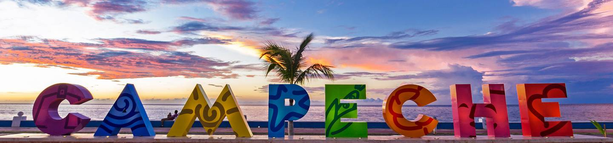
Arrival at Campeche Airport. Reception and transfer to your hotel.
Check in at hotel. Rest of the day at leisure.
Lunch and dinner at leisure. Lodging

DAY 02 – CAMPECHE – Visita de Ciudad

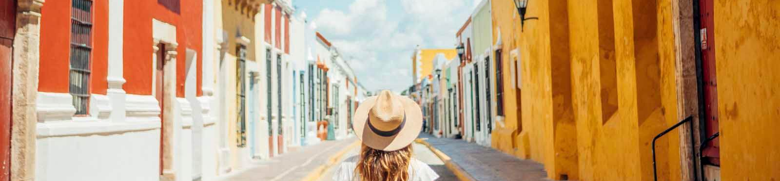

Breakfast at the hotel.

Campeche, cultural heritage of humanity offers a wide variety of attractions that will awaken in you a deep interest in the history of its walls. We begin with a guided tour of the main attractions of the city of Campeche. Colonial mansions, fortresses, museums and legends. Visit the walled city with its plaza, museums and bastions. Its fortresses and traditional neighborhoods.

Lunch and dinner on your own. Lodging.

DAY 03 – CAMPECHE – Calakmul y Balamkú

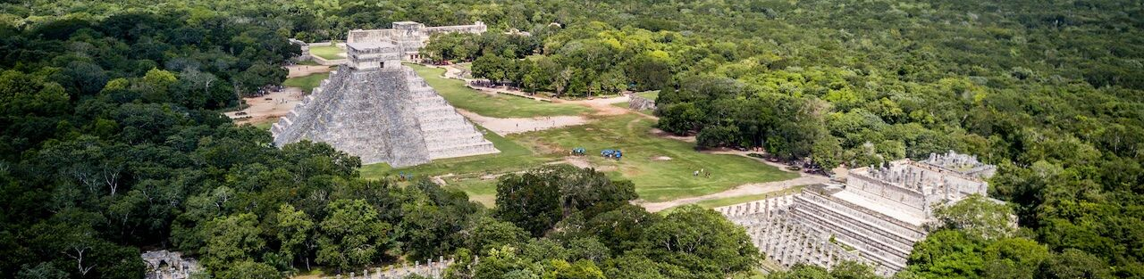

Breakfast at the hotel.
The biosphere reserve of Calakmul is a jungle place with a vast amount of exotic species and wildlife; and the imposing archaeological remains of this place, captivate every traveler who ventures to know it. An immersion to the jungle of kings. Visit to Calakmul, the most important political center of the Classic Maya; and Balamkú with its beautiful display of stucco-decorated monuments still in a perfect state of preservation. Lunch (without drinks).
Dinner at leisure. Lodging

DAY 04 – CAMPECHE – Los Chenes

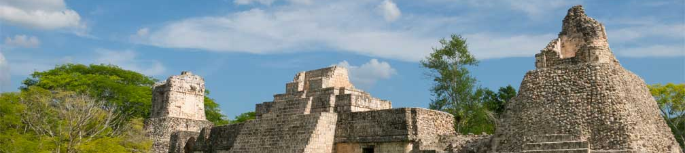

Breakfast at the hotel.
Tour through the region of the wells where one of the most beautiful architectural styles of the Mayan area was developed, represented in sites such as Hochob "Place where the corn cobs are kept" and you will see the Main Building, which is the Palace of the East, and the Archaeological Zone of Dzibilnocac "Painted Vault", where mounds corresponding to pyramidal bases, platforms, vaulted buildings and rooms are distributed and continuation of the trip to the Mayan community of Ich-Ek, where the ancestral tradition of the cultivation of the Mayan bee is taken up again. In the same region are located the caves of Xtacumbilxuna'an, where you can visit them with light and sound (caves only from Tuesday to Sunday). Lunch (without drinks).
Dinner at leisure. Lodging

DAY 05 – AGUASCALIENTES / OUT

Breakfast at the hotel.

At a convenient time transfer from your hotel to the airport to take your flight to your destination.

END of SERVICES

NOTE: The day of operation of the tours may vary.
** VALIDATE RATES WITH YOUR TRAVEL AGENT

CITY | NIGHTS | HOTELS 3* | HOTELS 4*
Campeche | 04 | Castelmar | Plaza Campeche

INCLUDED:
- TRANSPORTATION: Air-conditioned touristic unit
- ACCOMMODATION: Hotels according to your choice
- MEALS: 04 Breakfast, 02 Lunch
- VISITS: Those mentioned in the program.
- ESCORT GUIDE: Bilingual, certified by the Ministry of Tourism
NOT INCLUDED:

- Air tickets
- Food or services not mentioned
- Taxes at the airport
- Tips to guides or drivers.

IMPORTANT OBSERVATIONS:
- Due to the multiple changes that occur daily in tourism, these prices must be confirmed at the time of requesting the reservation.
- Rates subject to availability and changes without prior notice.
- Credit card payments are subject to a % commission.
- Please contemplate the schedule of Check in 15:00 hrs and Check Out 12:00 hrs.
- TRIPLE rooms only have 2 double beds.
- Transfers airport-hotel-airport are quoted in shared service, please consider flights arriving and departing between 06:00 and 22:00 hrs, otherwise it must be provided in private service and it will be necessary to re-quote.
- The waiting time for arrival transfers is 2 hours and 15 minutes. Once this time has elapsed, the passenger must transfer at his/her own expense.
- The tolerance time for departure transfer is 10 minutes, after this time the unit is withdrawn and you must transfer on your own to the apartment. * Under no circumstances will we be responsible for any extra expenses arising from this situation.
- Tours may change order according to the operations of the correspondent.

