PROGRAM
CALLEJONES, MINAS Y HACIENDAS
04 days/03 nights

(Ciudad de Guanajuato, Mina de “Secho”, Templo de Sr. De Villaseca, Casa Museo Gene Byron, Ex Hacienda San Gabriel de Barrera)

Minimum 2 persons.
Daily Departures

ITINERARY

DAY 01 – IN / GUANAJUATO

Arrival at Guanajuato international airport. Reception and transfer to hotel.

Check in at hotel. Rest of the day at leisure.

Lunch and dinner at leisure. Lodging

DAY 02 – GUANAJUATO – City Tour

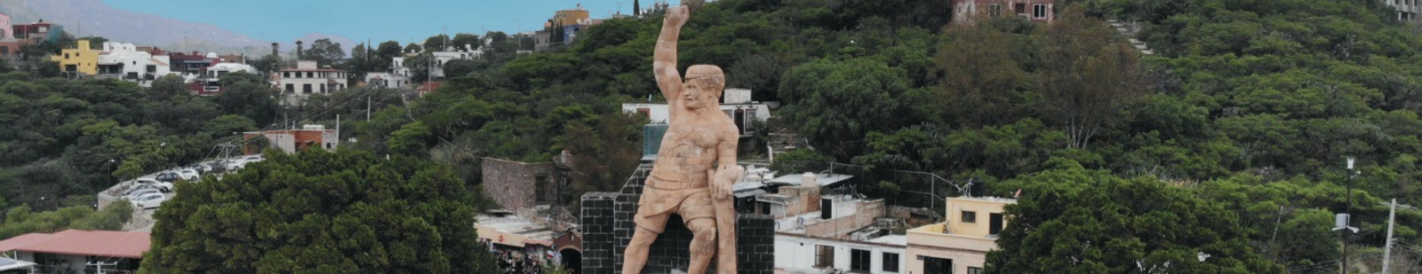

Breakfast at the hotel.

We visited
- Museum of the Mummies of Guanajuato
- Temple of La Valenciana
- Mine
- Tasting of sweets and liquors
- Pípila Viewpoint
- We pass in front of the Castillo de Santa Cecilia Hotel
- Subway street
- Typical tunnel of Guanajuato
- Paseo de la Presa (old residential area)
- La Olla Dam

- Escuela Normal Superior para Maestros (Teachers' College)
- We finish the tour in the center of the city, where we invite you to tour the beautiful Historic Center of Guanajuato, Cultural Heritage of Humanity.

Lunch and dinner on your own. Lodging.

DAY 03 – GUANAJUATO – Minas y Haciendas

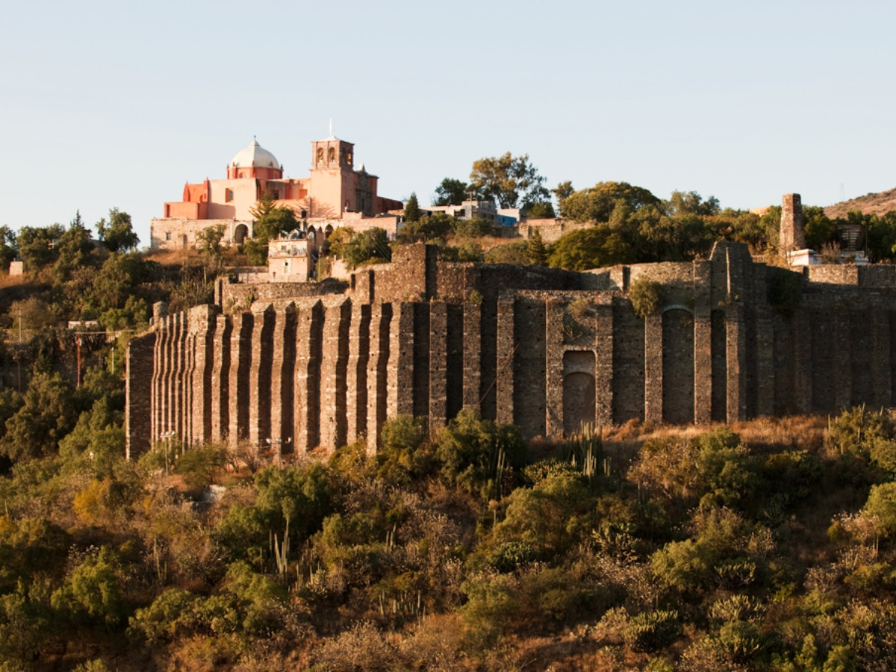

Breakfast at the hotel.

In this tour we will have the opportunity to know the mining of Guanajuato in all its expression. We will start by visiting (only the exterior) the San Juan de Rayas mine (XVI century), one of the oldest mines in Guanajuato, where we will observe its 425 meters deep shaft. We will go on an adventure to visit the mine of "Secho" and learn about the rudimentary system of mineral extraction, in the same place we will visit the Temple of Sr. De Villaseca and admire the baroque style facade of the eighteenth century. We will continue our tour visiting the Ex-Hacienda de Santa Ana, today Gene Byron House Museum, and closing with a flourish we will visit the Ex Hacienda San Gabriel de Barrera, one of the most beautiful. We will admire 18 gardens in different styles, as well as the original furniture of the Louis XV style house.

Lunch and dinner on your own. Lodging.

DAY 04 – GUANAJUATO/ OUT

Breakfast at the hotel.

At a convenient time transfer from your hotel to the airport to take your flight to your destination.

END OF SERVICES

NOTE: The day of operation of the tours may vary
** VALIDATE RATES WITH YOUR TRAVEL AGENT

CITY | NIGHTS | HOTELS 3*
Guanajuato | 03 | Misión Guanajuato
INCLUDED:
- TRANSPORTATION: Air-conditioned touristic unit
- ACCOMMODATION: Hotels according to your choice
- MEALS: 03 Breakfasts
- VISITS: Those mentioned in the program.
- ESCORT GUIDE: Bilingual, certified by the Ministry of Tourism

NOT INCLUDED:

- Air tickets
- Food or services not mentioned
- Taxes at the airport
- Tips to guides or drivers

IMPORTANT OBSERVATIONS:
- Due to the multiple changes that occur daily in tourism, these prices must be confirmed at the time of requesting the reservation.
- Rates subject to availability and changes without prior notice.
- Credit card payments are subject to a % commission.
- Please contemplate the schedule of Check in 15:00 hrs and Check Out 12:00 hrs.
- TRIPLE rooms only have 2 double beds.
- Transfers airport-hotel-airport are quoted in shared service, please consider flights arriving and departing between 06:00 and 22:00 hrs, otherwise it must be provided in private service and it will be necessary to re-quote.
- The waiting time for arrival transfers is 2 hours and 15 minutes. Once this time has elapsed, the passenger must transfer at his/her own expense.
- The tolerance time for departure transfer is 10 minutes, after this time the unit is withdrawn and you must transfer on your own to the apartment. * Under no circumstances will we be responsible for any extra expenses arising from this situation.
- Tours may change order according to the operations of the correspondent.

