PROGRAM
BELLEZA NATURAL DE YUCATÁN
05 days/04 nights

(Ciudad Antigua, Costa Esmeralda, Celestún, Cenotes)

Minimum 2 persons.
Daily Departures

ITINERARY

DAY 01 – IN / MÉRIDA
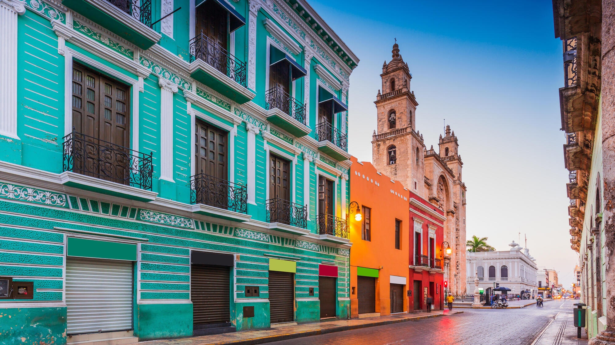
Arrival at merida airport. Reception and transfer to your hotel.

Check in at the hotel. Rest of the day at leisure.

Lunch and dinner on your own.
Lodging.

DAY 02 – MÉRIDA – Ciudad Antigua + Costa Esmeralda

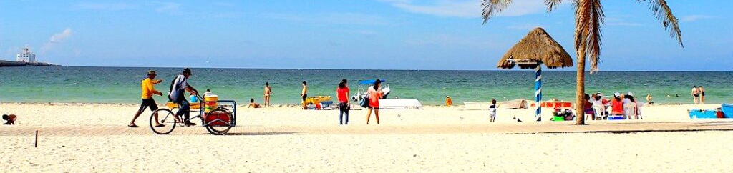
Breakfast at the hotel.

14 km from the city of Merida, Dzibilchaltun (the place where there are writings on flat stones) one of the great urban centers of the north of the Yucatan peninsula, the temple of the seven dolls, named for an offering that was found inside of seven clay figures in human form, It is a place where there are archaeo-astronomical phenomena that occur on the spring and autumn equinoxes, with a small but important Mayan museum as well as an open cenote type cenote at the edge of the earth. Progreso, a place of rest par excellence for thousands of Yucatecans, has the best beaches of emerald waters of the Yucatecan coast. It is a city and port located 36 km from the city of Merida, here you can walk along the boardwalk, enjoy the breeze and the delicious regional food, as well as the sea in several restaurants that line the boardwalk, we will spend a day of beach and ancient Mayan knowledge, a cultural adventure with a bit of sea and beach, after recreation we will return to Merida in just 25 min away.

Lunch and dinner on your own.
Lodging.

DAY 03 – MÉRIDA – Latidos verdes en Celestún

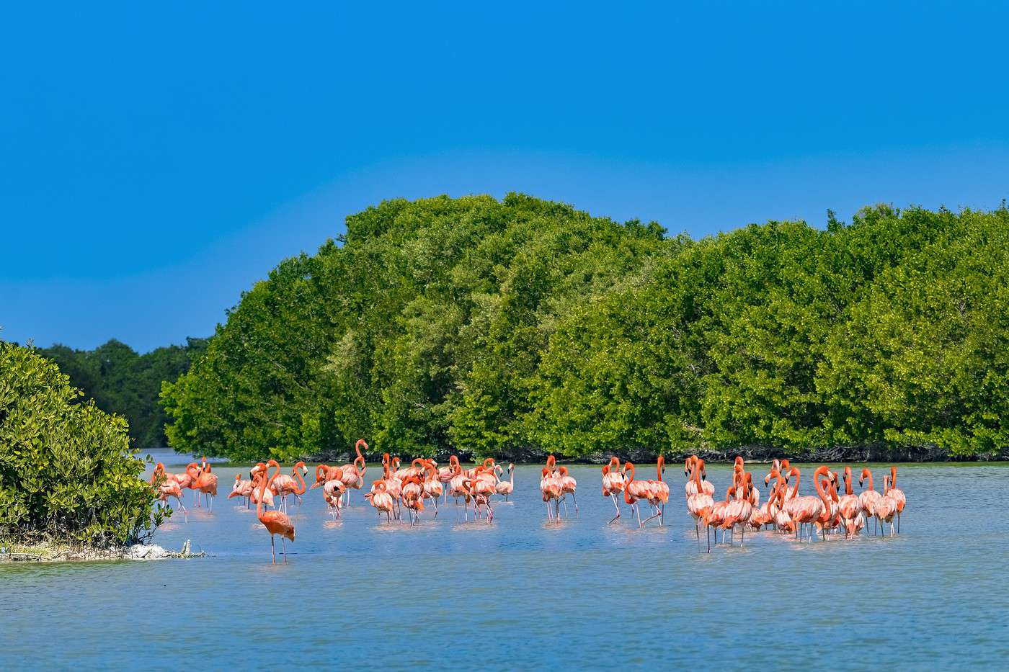
Breakfast at the hotel.

Celestun, natural paradise of the Gulf of Mexico, 90km from the city of Merida, biosphere reserve, is located in a coastal corridor of wetlands with the best conservation of the west of the peninsula, mangroves, dunes, petenes, lowland jungle and grasslands that protect the natural evolutionary processes that are the green heartbeat of this ecosystem. All in sight in a boat ride on the estuary for an hour and fifteen minutes where we also visit the feeding area of several birds such as flamingos, we will enter the boat in the mangrove trails to discover this ecosystem with a special balance, after the visit free time for lunch at a restaurant and be on the beach, and then return to Merida in a time of no more than an hour and a half drive.

Lunch and dinner on your own.
Lodging.

DAY 04 – MÉRIDA – Cenotes al borde del cráter

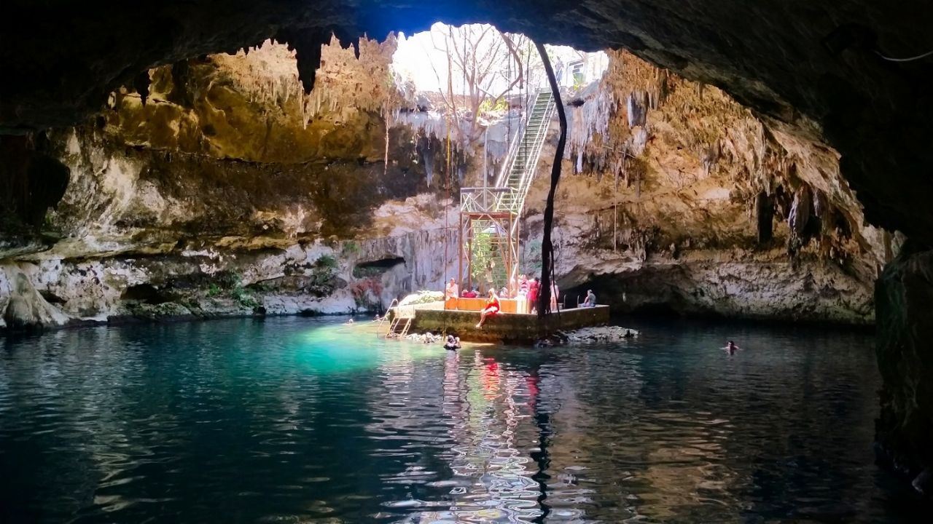
Breakfast at the hotel.

In this tour we will discover three of the most beautiful cenotes that exist in Yucatan. In this adventure we will tell you about several details you probably didn't know about the cenotes of the crater rim, such as the formation of some cenotes from the impact of the Chicxulub meteorite 65 million years ago and the deep relationship the ancient Maya had with their cenotes. Come prepared to swim and snorkel in the crystal clear waters of these natural formations that exist nowhere else in Mexico or the world. After the visit and swimming time, we will have time for lunch and then return to Merida.

Lunch and dinner on your own.
Lodging.

DAY 05 – MÉRIDA / OUT
Breakfast at the hotel.

At a convenient time transfer from your hotel to the airport to take your flight to your destination.

END OF SERVICES

NOTE: The day of operation of the tours may vary

** VALIDATE RATES WITH YOUR TRAVEL AGENT

CITY | NIGHTS | HOTELS 3* | HOTELS 4** | HOTELS SP*
Mérida | 04 | Marionetas | Villa Mercedes Curio | Rosas & Xocolate

INCLUDED:
- TRANSPORTATION: Air-conditioned touristic unit
- ACCOMMODATION: Hotels according to your choice
- MEALS: Daily Breakfast
- VISITS: Those mentioned in the program.
- ESCORT GUIDE: Bilingual, certified by the Ministry of Tourism
NOT INCLUDED:

- Air tickets
- Food or services not mentioned
- Taxes at the airport
- Tips to guides or drivers.

IMPORTANT OBSERVATIONS:
- Due to the multiple changes that occur daily in tourism, these prices must be confirmed at the time of requesting the reservation.
- Rates subject to availability and changes without prior notice.
- Credit card payments are subject to a % commission.
- Please contemplate the schedule of Check in 15:00 hrs and Check Out 12:00 hrs.
- TRIPLE rooms only have 2 double beds.
- Transfers airport-hotel-airport are quoted in shared service, please consider flights arriving and departing between 06:00 and 22:00 hrs, otherwise it must be provided in private service and it will be necessary to re-quote.
- The waiting time for arrival transfers is 2 hours and 15 minutes. Once this time has elapsed, the passenger must transfer at his/her own expense.
- The tolerance time for departure transfer is 10 minutes, after this time the unit is withdrawn and you must transfer on your own to the apartment. * Under no circumstances will we be responsible for any extra expenses arising from this situation.
- Tours may change order according to the operations of the correspondent.

