PROGRAM
BAJA CALIFORNIA Y SUS VINOS
05 days/04 nights

(Ciudad, Rosarito, Ensenada, Valle de Guadalupe)

Minimum 2 persons.
Daily Departures

ITINERARY

DAY 01 – IN / TIJUANA
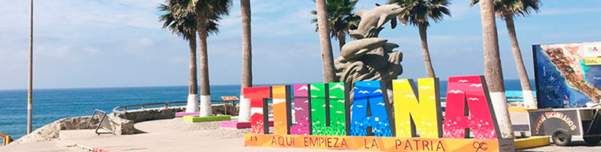

Arrival at Tijuana International Airport. Reception and transfer to your hotel.

Check in at hotel. Rest of the day at leisure.

Lunch and dinner at leisure. Lodging

DAY 02 –TIJUANA – Visita de Ciudad - Rosarito



Breakfast at the hotel.

This tour takes you to enjoy the best of two Baja California cities Tijuana, the busiest border city in the world, a young city with less than 150 years of history; cosmopolitan and an excellent location ideal for business and tourism.
Rosarito is a city with emerging art, here you will find beautiful beaches and you can also taste one of the dishes that have given worldwide fame to this city: Puerto Nuevo style lobster. Lunch (Drinks not included)

Dinner on your own. Lodging.

DAY 03 – TIJUANA – Ruta del Vino y queso – Ojos Negros - Ensenada

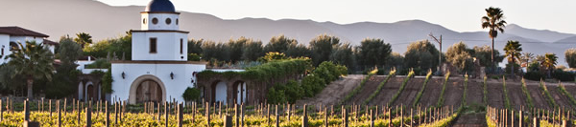

Breakfast at the hotel.

Baja California is the main Wine Route of Mexico, where most of the wine production is concentrated and also most of the wine houses in the country. Valle de Ojos Negros is one of the valleys with the best water supply, since it is located next to the Sierra de Juarez, where every year it rains and snows and all that water fills the aquifers of the Ojos Negros Valley, supplying its wells with water, which irrigates its fields and allows the cultivation of a great variety of vegetables, such as onions, tomatoes, chiles, grapes, watermelon, melon and other delicacies.

One of the most common uses of water is to irrigate pasture or fodder, which is used to feed the cattle, which are very numerous in the Ojos Negros Valley. Thus, thanks to the good presence of water wells, feed can be created for the cattle and this results in great production of dairy products, such as milk, butter, cottage cheese and various types of cheese. On this tour you will travel the famous Wine and Cheese Route of Baja California, an area internationally recognized for the good quality of its wines and cheeses.

Lunch and dinner on your own. Lodging.

DAY 04 – TIJUANA – Ruta del Vino en Valle de Guadalupe

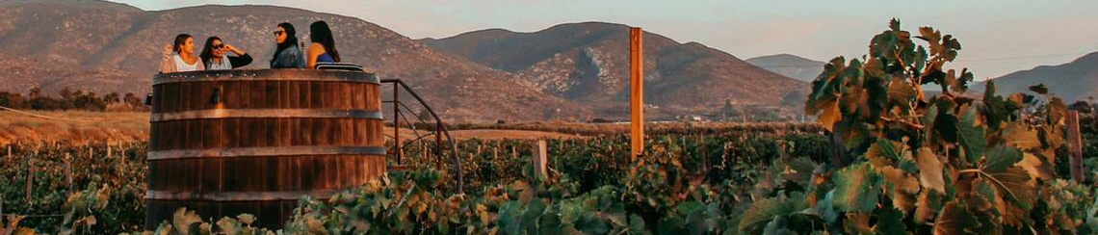

Breakfast at the hotel.

Follow the Wine Route to enter the Guadalupe Valley and taste the best Mexican wine! Ideal for: Families, Friends, Work, Congresses, Conventions, Religious Meetings who wish to enjoy the excellent vineyard area, enjoy wines, artisan products and excellent gastronomy, in addition to the beautiful landscapes in the vineyards. Delight yourself and taste the exquisite wines of the Guadalupe Valley in Tijuana, Baja California in the Wine Route Tour.

Learn about the process of making a good wine in a dynamic tour guided by an expert.
Visit the wineries and taste different varieties of wines and get to know beautiful landscapes in the vineyards of Baja California.

Lunch and dinner on your own. Lodging.

DAY 05 – TIJUANA/ OUT

Breakfast at the hotel.

At a convenient time transfer from your hotel to the airport to take your flight to your destination.

END of SERVICES

NOTE: The day of operation of the tours may vary.
** VALIDATE RATES WITH YOUR TRAVEL AGENT

CITY | NIGHTS | HOTELS 3* | HOTELS 4*
Tijuana | 04 | City Express Tijuana | Marriott Tijuana

INCLUDED:
- TRANSPORTATION: Air-conditioned touristic unit
- ACCOMMODATION: Hotels according to your choice
- MEALS: 04 Breakfast, 01 Lunch
- VISITS: Those mentioned in the program.
- ESCORT GUIDE: Bilingual, certified by the Ministry of Tourism
NOT INCLUDED:

- Air tickets
- Food or services not mentioned
- Taxes at the airport
- Tips to guides or drivers.

IMPORTANT OBSERVATIONS:
- Due to the multiple changes that occur daily in tourism, these prices must be confirmed at the time of requesting the reservation.
- Rates subject to availability and changes without prior notice.
- Credit card payments are subject to a % commission.
- Please contemplate the schedule of Check in 15:00 hrs and Check Out 12:00 hrs.
- TRIPLE rooms only have 2 double beds.
- Transfers airport-hotel-airport are quoted in shared service, please consider flights arriving and departing between 06:00 and 22:00 hrs, otherwise it must be provided in private service and it will be necessary to re-quote.
- The waiting time for arrival transfers is 2 hours and 15 minutes. Once this time has elapsed, the passenger must transfer at his/her own expense.
- The tolerance time for departure transfer is 10 minutes, after this time the unit is withdrawn and you must transfer on your own to the apartment. * Under no circumstances will we be responsible for any extra expenses arising from this situation.
- Tours may change order according to the operations of the correspondent.

