PROGRAM
BAHIAS DE MARAVILLA Y SOL
05 days/04 nights

(Ixtapa Zihuatanejo, Playa la ropa, Kayak en Potosí)

Minimum 4 persons.
Daily Departures

ITINERARY

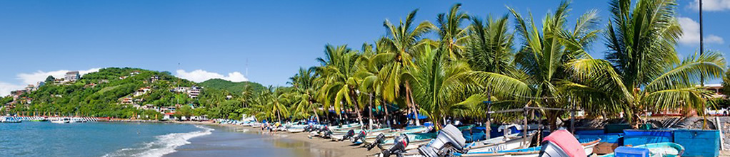
DAY 01 – IN / IXTAPA ZIHUATANEJO
Arrival at the international airport in Zihuatanejo. Reception and transfer to your hotel.
Check in at hotel. Rest of the day at leisure.
Lunch and dinner at leisure.
Lodging

DAY 02 – IXTAPA ZIHUATANEJO – Living Ixtapa & Zihuatanejo

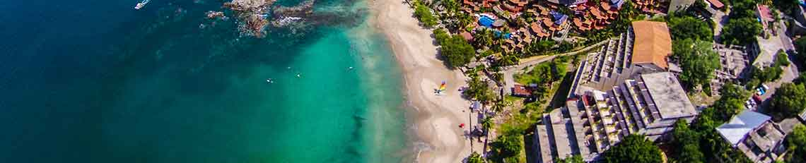

Morning tour of Ixtapa and Zihuatanejo, known for its beautiful beaches and spectacular swimming spots, as well as its beautiful streets full of beauty and culture. Ixtapa Zihuatanejo is a doubly pleasurable place for a weekend trip. Visit the main points of downtown and the Ixtapa lookout point to take panoramic photos. Free time at leisure.

Lodging all inclusive.

DAY 03 – IXTAPA ZIHUATANEJO – Playa la Ropa con almuerzo

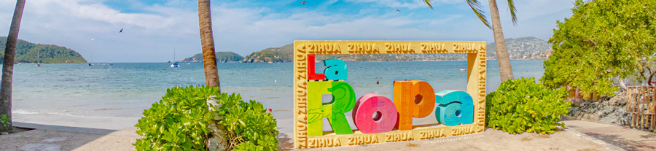

Visit Playa la ropa wonderful bay has recently been awarded as one of the best and most romantic beaches to visit in Mexico by the world's largest travel platform. Its name comes from an anecdote where in colonial times a ship loaded with fine fabrics: muslins, woven products from Bombay, ribbons, shawls and stockings from China, sank off the coast of Guerrero and all these materials reached the beach. Lunch of shrimp or fish and 2 drinks included. Time for shopping.

Lodging all inclusive.

DAY 04 – IXTAPA ZIHUATANEJO – Kayak en Potosi

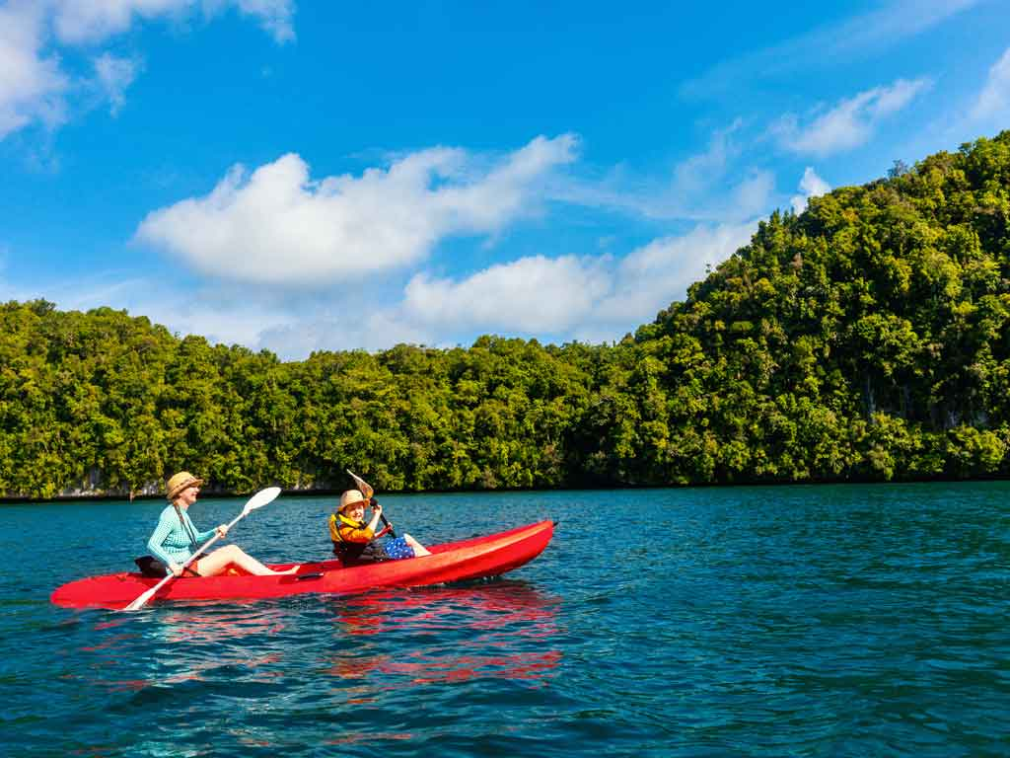
Departure in the morning from the hotel. Transfer to the Potosi Lagoon where the sea and the lagoon meet. Have a relaxing kayak ride on the lagoon, admire the flora and fauna that occurs in the mangroves of this area and where you can relax all your senses. Includes lunch with 2 drinks. Return to your hotel.
Lodging all inclusive.

DAY 05 – IXTAPA ZIHUATANEJO / OUT

Breakfast at the hotel.

At a convenient time transfer from your hotel to the airport to take the flight to your destination.

END OF SERVICES

NOTE: The day of operation of the tours may vary.

** VALIDATE RATES WITH YOUR TRAVEL AGENT

CITY | NIGHTS | 5*
Ixtapa Zihuatanejo | 04 | Barceló Ixtapa

INCLUDED:
- TRANSPORTATION: Air-conditioned touristic unit
- ACCOMMODATION: Hotels according to your choice
- MEALS: All inclusive plan, 02 lunch’s
- VISITS: Those mentioned in the program.
- ESCORT GUIDE: Bilingual, certified by the Ministry of Tourism
NOT INCLUDED:

- Air tickets
- Food or services not mentioned
- Taxes at the airport
- Tips to guides or drivers.
IMPORTANT OBSERVATIONS:

1. Due to the multiple changes that occur daily in tourism, these prices must be confirmed at the time of requesting the reservation.
2. Rates subject to availability and changes without prior notice.
3. Credit card payments are subject to a % commission.
4. Please contemplate the schedule of Check in 15:00 hrs and Check Out 12:00 hrs.
5. TRIPLE rooms only have 2 double beds.
6. Transfers airport-hotel-airport are quoted in shared service, please consider flights arriving and departing between 06:00 and 22:00 hrs, otherwise it must be provided in private service and it will be necessary to re-quote.
7. The waiting time for arrival transfers is 2 hours and 15 minutes. Once this time has elapsed, the passenger must transfer at his/her own expense.
8. The tolerance time for departure transfer is 10 minutes, after this time the unit is withdrawn and you must transfer on your own to the apartment. * Under no circumstances will we be responsible for any extra expenses arising from this situation.
9. Tours may change order according to the operations of the correspondent.

