PROGRAM
AVENTURATE EN IXTAPA
05 days/04 nights

(Ixtapa Zihuatanejo, Kayak en Potosí, Tirolesas, Snorkel en Playa Manzanillo)

Minimum 4 persons.
Daily Departures

ITINERARY

DAY 01 – IN / IXTAPA ZIHUATANEJO
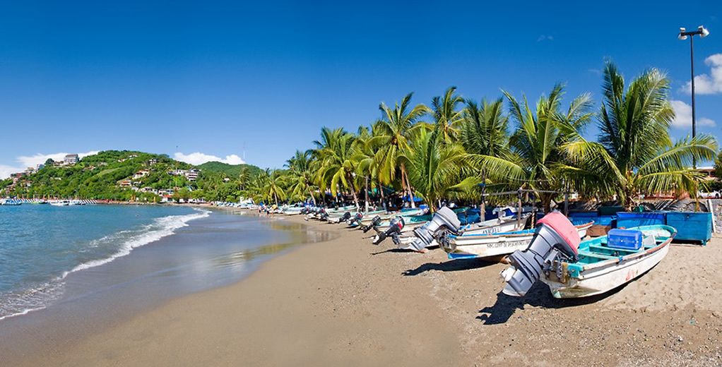
Arrival at the international airport in Zihuatanejo. Reception and transfer to your hotel.
Check in at hotel. Rest of the day at leisure.
Lunch and dinner at leisure. Lodging

DAY 02 – IXTAPA ZIHUATANEJO – Kayak en Potosí

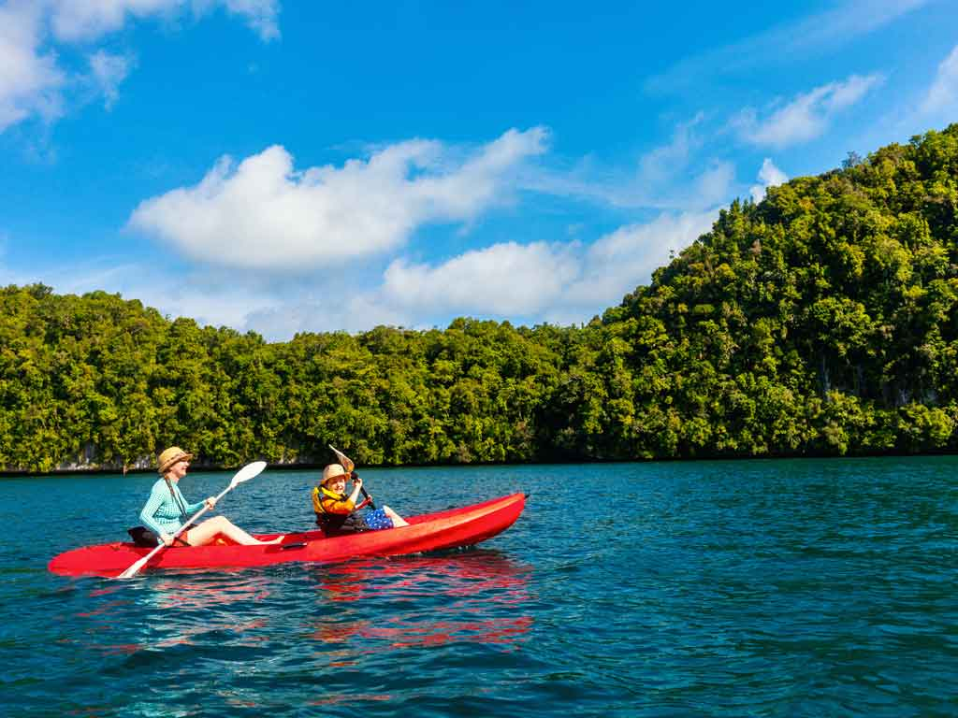
Departure in the morning from the hotel. Transfer to the Potosi Lagoon where the sea and the lagoon meet. Have a relaxing kayak ride on the lagoon, admire the flora and fauna that occurs in the mangroves of this area and where you can relax all your senses. Includes lunch with 2 drinks. Return to your hotel.
Lodging all inclusive.

DAY 03 – IXTAPA ZIHUATANEJO – Tirolesas

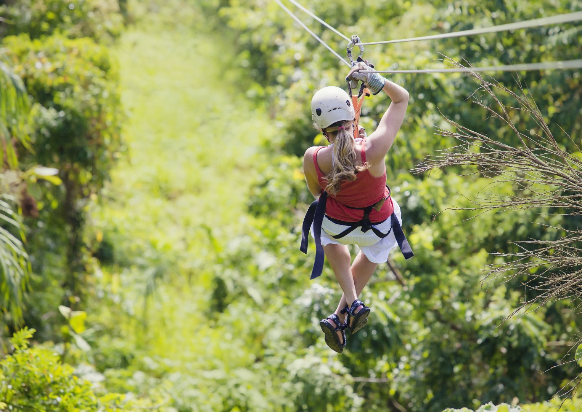

Just 15 minutes from the Hotel Zone enjoy a tour full of adrenaline and fun, where you can enjoy 11 zip lines, moving and hanging bridges, 22 activities in total, hanging bridges and the monkey bridge. The tour begins with an orientation briefing where safety and security rules are explained before starting this fantastic adventure. Light snacks and 2 drinks included. Return to the hotel.
Lodging all inclusive.

DAY 04 – IXTAPA ZIHUATANEJO – Snorkel en playa manzanillo



In the morning departure from the hotel and catamaran ride along the bay of Zihuatanejo to Manzanillo beach, a charming desert beach located between Playa Larga and Zihuatanejo Bay, where you can snorkel and admire the flora and fauna. On the way back, if the air allows it, the spinnaker activity. National open bar and snacks included.
Lodging all inclusive.

DAY 05 – IXTAPA ZIHUATANEJO / OUT

Breakfast at the hotel.

At a convenient time transfer from your hotel to the airport to take the flight to your destination.

END OF SERVICES
** VALIDATE RATES WITH YOUR TRAVEL AGENT
NOTE: The day of operation of the tours may vary.

CITY | NIGHTS | 5*
Ixtapa Zihuatanejo | 04 | Barceló Ixtapa

INCLUDED:
- TRANSPORTATION: Air-conditioned touristic unit
- ACCOMMODATION: Hotels according to your choice
- MEALS: All inclusive plan, 01 Lunch in Kayak with 02 drinks, Snacks
and 02 drinks in with 02 drinks, Snacks and 02 drinks in zip
lines, Open bar and snacks in snorkel.
- VISITS: Those mentioned in the program.
- ESCORT GUIDE: Bilingual, certified by the Ministry of Tourism
NOT INCLUDED:

- Air tickets
- Food or services not mentioned
- Taxes at the airport
- Tips to guides or drivers.

IMPORTANT OBSERVATIONS:
- Due to the multiple changes that occur daily in tourism, these prices must be confirmed at the time of requesting the reservation.
- Rates subject to availability and changes without prior notice.
- Credit card payments are subject to a % commission.
- Please contemplate the schedule of Check in 15:00 hrs and Check Out 12:00 hrs.
- TRIPLE rooms only have 2 double beds.
- Transfers airport-hotel-airport are quoted in shared service, please consider flights arriving and departing between 06:00 and 22:00 hrs, otherwise it must be provided in private service and it will be necessary to re-quote.
- The waiting time for arrival transfers is 2 hours and 15 minutes. Once this time has elapsed, the passenger must transfer at his/her own expense.
- The tolerance time for departure transfer is 10 minutes, after this time the unit is withdrawn and you must transfer on your own to the apartment. * Under no circumstances will we be responsible for any extra expenses arising from this situation.
- Tours may change order according to the operations of the correspondent.

