PROGRAM
AVENTURA EN TIJUANA
04 days/03 nights

(Ciudad, Rosarito, Tecate)

Minimum 2 persons.
Daily Departures

ITINERARY

DAY 01 – IN / TIJUANA
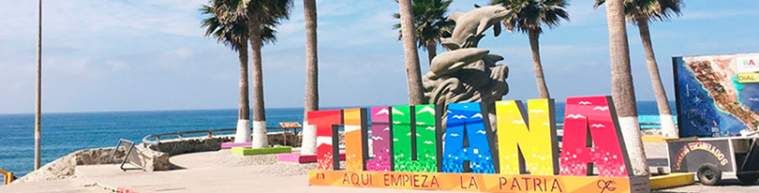

Arrival at Tijuana International Airport. Reception and transfer to your hotel.

Check in at hotel. Rest of the day at leisure.

Lunch and dinner at leisure. Lodging

DAY 02 –TIJUANA – Visita de Ciudad - Rosarito



Breakfast at the hotel.

This tour takes you to enjoy the best of two Baja California cities Tijuana, the busiest border city in the world, a young city with less than 150 years of history; cosmopolitan and an excellent location ideal for business and tourism.
Rosarito is a city with emerging art, here you will find beautiful beaches and you can also taste one of the dishes that have given worldwide fame to this city: Puerto Nuevo style lobster. Lunch (Drinks not included)

Dinner on your own. Lodging.

DAY 03 – TIJUANA – Tecate

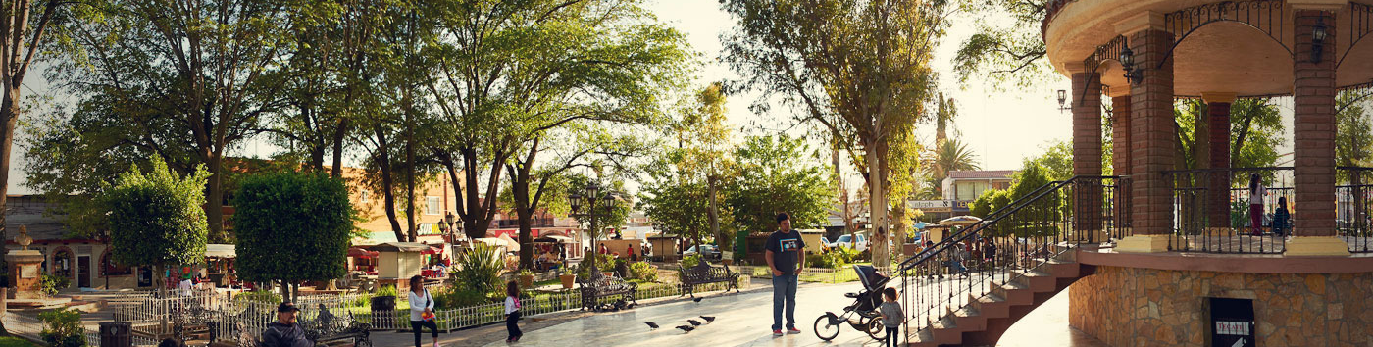

Breakfast at the hotel.

Relax and enjoy wines, beers, breads and dreamy landscapes in this magical town, located in the north of Baja California. Ideal for: enjoying ecotourism in direct contact with nature, or intense relaxation in one of its famous ranch-spas.
Tecate is defined by its colonial and picturesque atmosphere. It is a small city that is reached through a journey through cattle ranches, impressive mountains and colossal rock structures. Arriving in the city you can smell the smell emanating from the Tecate brewery, one of its main industries, so it is considered a point of interest where they offer tours and tastings.

Lunch and dinner on your own. Lodging.

DAY 04 – TIJUANA/ OUT

Breakfast at the hotel.

At a convenient time transfer from your hotel to the airport to take your flight to your destination.

END of SERVICES

NOTE: The day of operation of the tours may vary.
** VALIDATE RATES WITH YOUR TRAVEL AGENT

CITY | NIGHTS | HOTELS 3* | HOTELS 4*
Tijuana | 03 | City Express Tijuana | Marriott Tijuana

INCLUDED:
- TRANSPORTATION: Air-conditioned touristic unit
- ACCOMMODATION: Hotels according to your choice
- MEALS: 03 Breakfast, 01 Lunch
- VISITS: Those mentioned in the program.
- ESCORT GUIDE: Bilingual, certified by the Ministry of Tourism
NOT INCLUDED:

- Air tickets
- Food or services not mentioned
- Taxes at the airport
- Tips to guides or drivers.

IMPORTANT OBSERVATIONS:
- Due to the multiple changes that occur daily in tourism, these prices must be confirmed at the time of requesting the reservation.
- Rates subject to availability and changes without prior notice.
- Credit card payments are subject to a % commission.
- Please contemplate the schedule of Check in 15:00 hrs and Check Out 12:00 hrs.
- TRIPLE rooms only have 2 double beds.
- Transfers airport-hotel-airport are quoted in shared service, please consider flights arriving and departing between 06:00 and 22:00 hrs, otherwise it must be provided in private service and it will be necessary to re-quote.
- The waiting time for arrival transfers is 2 hours and 15 minutes. Once this time has elapsed, the passenger must transfer at his/her own expense.
- The tolerance time for departure transfer is 10 minutes, after this time the unit is withdrawn and you must transfer on your own to the apartment. * Under no circumstances will we be responsible for any extra expenses arising from this situation.
- Tours may change order according to the operations of the correspondent.

