PROGRAM
ATARDECER EN LOS CABOS
05 days/04 nights

(Ciudad, Camello Safari, Cabo San Lucas)

Minimum 2 persons.
Daily Departures

ITINERARY

DAY 01 – IN / LOS CABOS
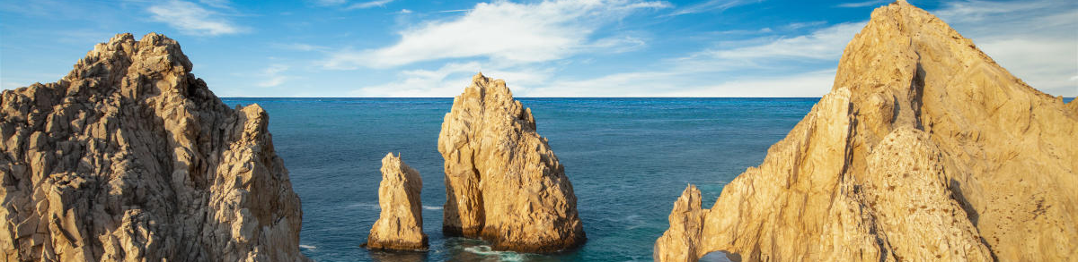

Arrival at Los Cabos International Airport. Reception and transfer to your hotel.

Check in at hotel. Rest of the day at leisure.

Lunch and dinner at leisure. Lodging

DAY 02 –LOS CABOS– Visita de Ciudad

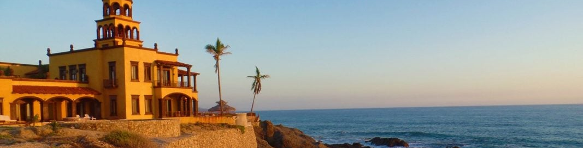

Breakfast at the hotel.

The quirky and eclectic town of Todos Santos, located between La Paz and Cabo San Lucas, has a long and fascinating history that you will learn from our certified bilingual tour guides. This tour is perfect for those who enjoy learning about the culture and traditions of the places they visit. A visit to Hotel California is included in the program along with a selection of unique galleries.

Lodging all inclusive.

DAY 03 – LOS CABOS – Camello Safari

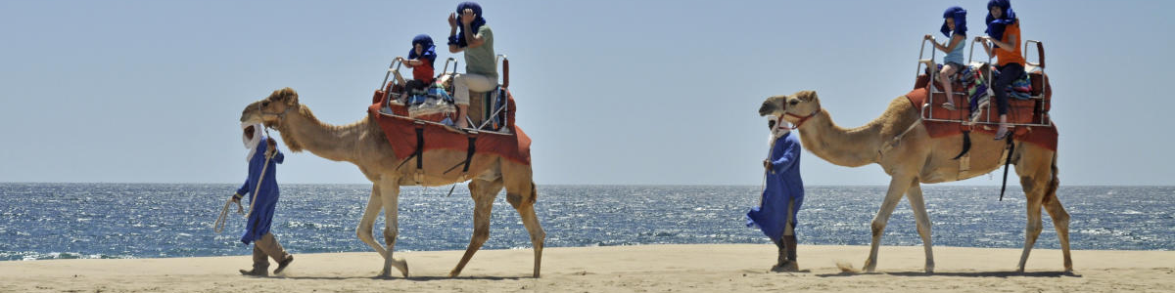

Breakfast at the hotel.

Get ready for a spectacular ride on a virgin beach of the Pacific Ocean aboard a camel while enjoying the view on this unforgettable eco tour. Meet our camels in person and capture the moment with a photo. Discover the wonders of Baja California Sur's desert flora and fauna, history and regional culture on an interactive tour with an expert guide. Learn about the culture of Tequila and Damiana, a regional liquor, while savoring a delicious Mexican meal. Lunch included.

Lodging all inclusive.

DAY 04 – LOS CABOS – Al Final de la Tierra

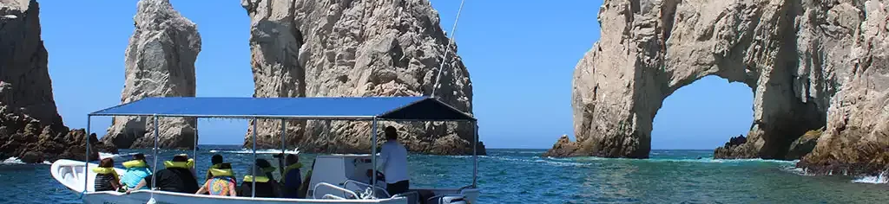

Breakfast at the hotel.

You will be able to appreciate the contrast between the calm waters of the Sea of Cortez and the swell of the Pacific Ocean. The experience of the fusion between the Sea of Cortez and the Pacific Ocean is a rare phenomenon of Mother Nature around the world. This exciting and enjoyable tour focuses on the main attractions of our sea and combines beach time at Pelicano Rock, and if conditions allow to disembark you can explore La Playa del Amor, Playa del Divorcio, La Cueva de San Andres, the window to the Pacific. Finally you can enjoy shopping time in Cabo San Lucas.

Lodging all inclusive.

DAY 05 – LOS CABOS/ OUT

Breakfast at the hotel.

At a convenient time transfer from your hotel to the airport to take your flight to your destination.

END of SERVICES

NOTE: The day of operation of the tours may vary.
** VALIDATE RATES WITH YOUR TRAVEL AGENT

CITY | NIGHTS | HOTELS 4** o 5*
Los Cabos | 04 | Grand Fiesta Americana Los Cabos Golf & Spa o Similar

INCLUDED:
- TRANSPORTATION: Air-conditioned touristic unit
- ACCOMMODATION: Hotels according to your choice
- MEALS: All Inclusive
- VISITS: Those mentioned in the program.
- ESCORT GUIDE: Bilingual, certified by the Ministry of Tourism
NOT INCLUDED:

- Air tickets
- Food or services not mentioned
- Taxes at the airport
- Tips to guides or drivers.

IMPORTANT OBSERVATIONS:
- Due to the multiple changes that occur daily in tourism, these prices must be confirmed at the time of requesting the reservation.
- Rates subject to availability and changes without prior notice.
- Credit card payments are subject to a % commission.
- Please contemplate the schedule of Check in 15:00 hrs and Check Out 12:00 hrs.
- TRIPLE rooms only have 2 double beds.
- Transfers airport-hotel-airport are quoted in shared service, please consider flights arriving and departing between 06:00 and 22:00 hrs, otherwise it must be provided in private service and it will be necessary to re-quote.
- The waiting time for arrival transfers is 2 hours and 15 minutes. Once this time has elapsed, the passenger must transfer at his/her own expense.
- The tolerance time for departure transfer is 10 minutes, after this time the unit is withdrawn and you must transfer on your own to the apartment. * Under no circumstances will we be responsible for any extra expenses arising from this situation.
- Tours may change order according to the operations of the correspondent.

