PROGRAM

ARTESANIAS Y ARQUEOLOGIA EN MICHOACAN
06 days/05 nights

(City Tours, Tlalpujahua, Camecuaro, Zamora, Uruapan)

Minimum 2 persons.
Daily Departures

ITINERARY

DAY 01 – IN / MORELIA
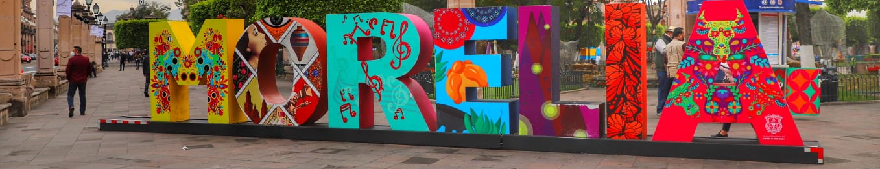

Arrival at Morelia's international airport. Reception and transfer to your hotel.

Check in at hotel. Rest of the day at leisure.

Lunch and dinner at leisure. Lodging

DAY 02 – MORELIA – City Tour

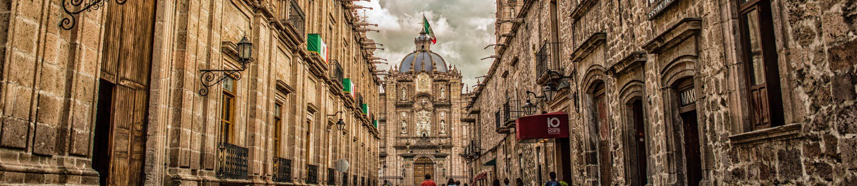

Breakfast at the hotel.

Walk through the streets of the Historic Center of Morelia, Michoacán and the interior of several colonial buildings, learning about its history and marveling at its unique architecture. You will have the fortune to see the famous aqueduct of Morelia, the Sanctuary of the Virgin of Guadalupe, the Fray Antonio de San Miguel Causeway, Fuente de las Tarascas, and finally walk through the great Cathedral, Government Palace, Palace of Justice, Birthplace of Morelos, Colegio de San Nicolas, Library and Clavijero Palace, the Temple and Conservatory of the Roses.

Lunch and dinner at leisure. Lodging

DAY 03 – MORELIA – Tlalpujahua

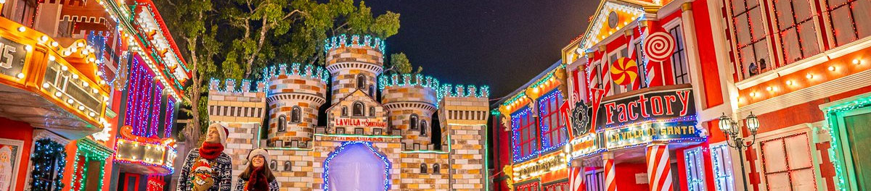

Breakfast at the hotel.

In this tour we will visit the center of Tlalpujahua, the sunken temple, as well as know its history and admire the house of santa, a place where they exhibit and sell Christmas crafts of the region, we will also visit the Christmas village where we will find workshops of spheres, and finally we will have the great visit to the temple of Our Lady of Carmen in Tlalpujahua.

Lunch and dinner at leisure. Lodging

DAY 04 – MORELIA – Camecuaro + Zamora

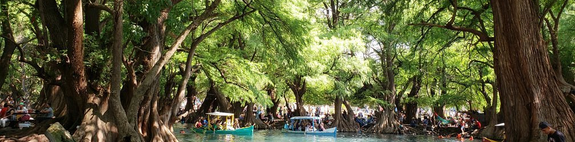

Breakfast at the hotel.

In this tour we will visit the Camecuaro Lake, representative for the roots of the "ahuehuetes" trees that dress the beauty of the place, we will also visit the center of Zamora where we will see its beautiful architecture mostly neo-gothic of its ancient and recent temples such as the Temple of San Francisco, the Cathedral and the imposing Sanctuary of Guadalupe that stands out from any point of the city since it is undoubtedly the highest in the Mexican Republic.

Lunch and dinner at leisure. Lodging

DAY 05 – MORELIA – Uruapan

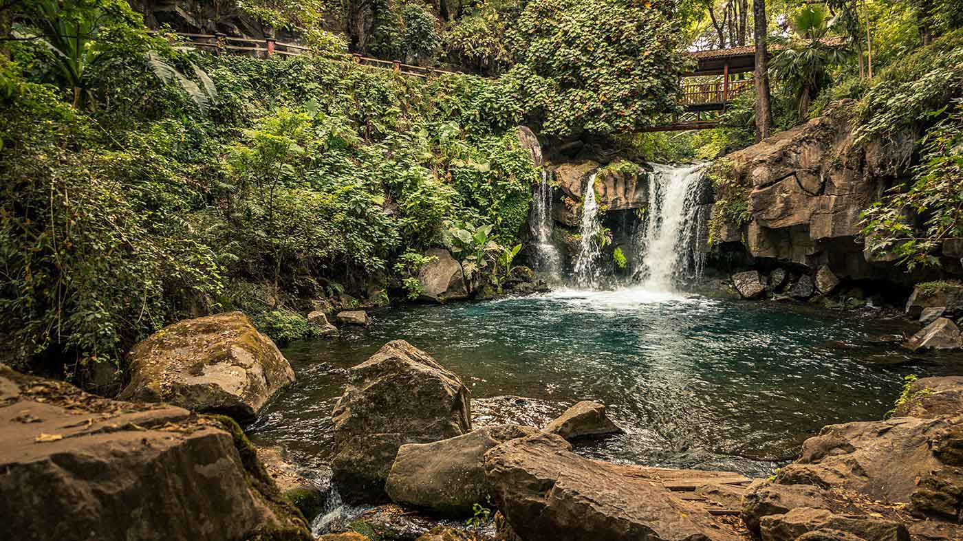

Breakfast at the hotel.

Ancient city with pre-Hispanic settlements that has become the second most important city in Michoacán. It has been called "The orchard of Michoacán" or "World capital of the avocado" due to the enormous cultivation of this product in the surrounding area. Famous for the production of bateas, jícaras, masks, boxes and other wooden objects, artistically decorated with a painting and carving technique that dates back to pre-Columbian times.

Lunch and dinner at leisure. Lodging

DAY 06 – MORELIA/OUT

Breakfast at the hotel.

At a convenient time transfer from your hotel to the airport to take the flight to your destination.

END OF SERVICES

** VALIDATE RATES WITH YOUR TRAVEL AGENT

CITY | NIGHTS | HOTELS 3* | HOTELS 4*
Morelia | 05 | Casino Morelia | De la Soledad

INCLUDED:
- TRANSPORTATION: Air-conditioned touristic unit
- ACCOMMODATION: Hotels according to your choice
- MEALS: 05 Breakfast
- VISITS: Those mentioned in the program.
- ESCORT GUIDE: Bilingual, certified by the Ministry of Tourism

NOT INCLUDED:

- Air tickets
- Food or services not mentioned
- Taxes at the airport
- Tips to guides or drivers.

IMPORTANT OBSERVATIONS:
- Due to the multiple changes that occur daily in tourism, these prices must be confirmed at the time of requesting the reservation.
- Rates subject to availability and changes without prior notice.
- Credit card payments are subject to a % commission.
- Please contemplate the schedule of Check in 15:00 hrs and Check Out 12:00 hrs.
- TRIPLE rooms only have 2 double beds.
- Transfers airport-hotel-airport are quoted in shared service, please consider flights arriving and departing between 06:00 and 22:00 hrs, otherwise it must be provided in private service and it will be necessary to re-quote.
- The waiting time for arrival transfers is 2 hours and 15 minutes. Once this time has elapsed, the passenger must transfer at his/her own expense.
- The tolerance time for departure transfer is 10 minutes, after this time the unit is withdrawn and you must transfer on your own to the apartment. * Under no circumstances will we be responsible for any extra expenses arising from this situation.
- Tours may change order according to the operations of the correspondent.

