PROGRAM
ARQUITECTURA, RUINAS Y TEQUILA
04 days/03 nights

(City Tour, Sitio Arqueológico de Plazuelas, Tequilera Corralejo, Mineral de Pozos)

Minimum 2 persons.
Daily Departures

ITINERARY

DAY 01 – IN / GUANAJUATO


Arrival at Guanajuato international airport. Reception and transfer to hotel.
Check in at the hotel. Rest of the day at leisure.
Lunch and dinner on your own. Lodging.

DAY 02 – GUANAJUATO – City Tour

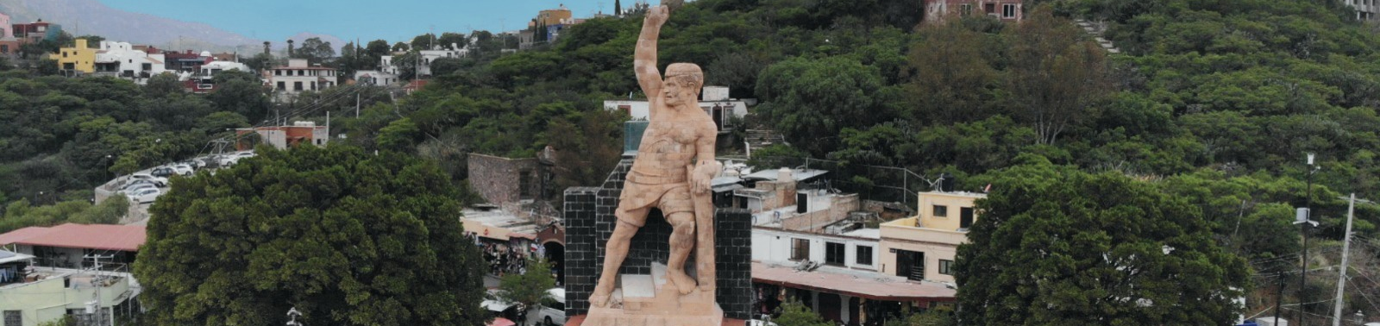

Breakfast at the hotel.

We visited
- Museum of the Mummies of Guanajuato
- Temple of La Valenciana
- Mine
- Tasting of sweets and liquors
- Pípila Viewpoint
- We pass in front of the Castillo de Santa Cecilia Hotel
- Subway street
- Typical tunnel of Guanajuato
- Paseo de la Presa (old residential area)
- La Olla Dam
- Escuela Normal Superior para Maestros (Teachers' College)
- We finish the tour in the center of the city, where we invite you to tour the beautiful Historic Center of Guanajuato, Cultural Heritage of Humanity.

Lunch and dinner on your own. Lodging.

DAY 03 – GUANAJUATO – Plazuelas + Tequilera

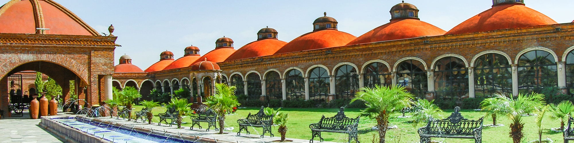

Breakfast at the hotel.

We will go to the ruins of Plazuelas, archaeological site recently opened to the public, located in Pénjamo, Guanajuato, but first we will visit the Tequilera Corralejo, site where we will know the elaboration of different types of Tequilas of that brand, as well as its Potro Beer, from there, the transfer to Plazuelas. After visiting these places we will go to Mineral de Pozos, this mining town was in its time of great importance and boom, it has more than 400 abandoned mines and is considered a magical town of Mexico. We will see a pre-Hispanic instrument workshop and you will be able to appreciate the impressive Jesuit Ovens. Return to the city of Guanajuato.

Lunch and dinner on your own. Lodging.

DAY 04 – GUANAJUATO/ OUT

Breakfast at the hotel.

At a convenient time transfer from your hotel to the airport to take your flight to your destination.

END of SERVICES

NOTE: The day of operation of the tours may vary.
** VALIDATE RATES WITH YOUR TRAVEL AGENT

CITY | NIGHTS | HOTELS 3*
Guanajuato | 03 | Misión Guanajuato

INCLUDED:
- TRANSPORTATION: Air-conditioned touristic unit
- ACCOMMODATION: Hotels according to your choice
- MEALS: 03 Breakfast
- VISITS: Those mentioned in the program.
- ESCORT GUIDE: Bilingual, certified by the Ministry of Tourism
NOT INCLUDED:

- Air tickets
- Food or services not mentioned
- Taxes at the airport
- Tips to guides or drivers.

IMPORTANT OBSERVATIONS:
- Due to the multiple changes that occur daily in tourism, these prices must be confirmed at the time of requesting the reservation.
- Rates subject to availability and changes without prior notice.
- Credit card payments are subject to a % commission.
- Please contemplate the schedule of Check in 15:00 hrs and Check Out 12:00 hrs.
- TRIPLE rooms only have 2 double beds.
- Transfers airport-hotel-airport are quoted in shared service, please consider flights arriving and departing between 06:00 and 22:00 hrs, otherwise it must be provided in private service and it will be necessary to re-quote.
- The waiting time for arrival transfers is 2 hours and 15 minutes. Once this time has elapsed, the passenger must transfer at his/her own expense.
- The tolerance time for departure transfer is 10 minutes, after this time the unit is withdrawn and you must transfer on your own to the apartment. * Under no circumstances will we be responsible for any extra expenses arising from this situation.
- Tours may change order according to the operations of the correspondent.

