PROGRAM
AMOR EN SAN MIGUEL
04 days/03 nights

(Thermal Waters, Hot Air balloon flight)

Minimum 2 persons.
Daily Departures

ITINERARY

DAY 01 – IN / GUANAJUATO – SAN MIGUEL DE ALLENDE


Arrival at Guanajuato international airport. Reception and transfer to hotel in San Miguel de Allende.

Check in at the hotel. Rest of the day at leisure.

Lunch and dinner on your own. Lodging.

DAY 02 – SAN MIGUEL DE ALLENDE– Thermal Waters

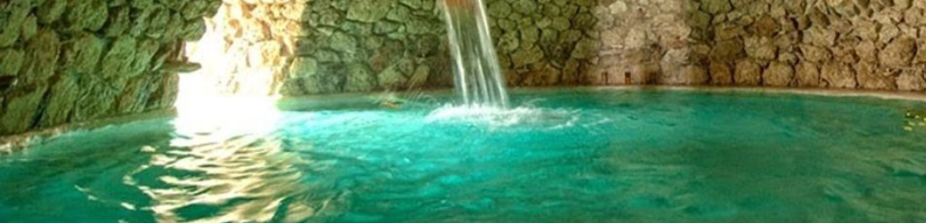

Breakfast at the hotel.

Visit the thermal baths to relieve your tensions and relax your muscles in one of the 10 thermal pools of the Escondido Place spa. In a privileged setting, enjoy its gardens, lakes and water lilies and, of course, its relaxing indoor and outdoor pools. For a truly healing experience, take advantage of the excellent spa and massage services available.

Lunch and dinner on your own. Lodging.

DAY 03 – SAN MIGUEL DE ALLENDE – Hot Air Ballon flight with breakfast

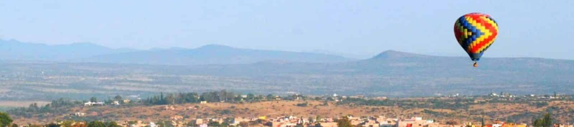

Early in the morning we will take off and fly over the Historic Center and the San Miguel Arcangel Parish, where you will live the experience of flying very close to the ground or above the clouds, depending on the air currents. Finally, we will have breakfast at Café Monet restaurant with a toast.

Lunch and dinner on your own. Lodging.

DAY 04 – SAN MIGUEL DE ALLENDE/ OUT

Breakfast at the hotel.

At a convenient time transfer from your hotel to the airport to take your flight to your destination.

END of SERVICES

NOTE: The day of operation of the tours may vary.

** VALIDATE RATES WITH YOUR TRAVEL AGENT

CITY | NIGHTS | HOTELS 3* | HOTELS 4* | HOTELS 4*
San Miguel de Allende | 03 | Misión San Miguel | Real de Minas San Miguel | Casa Primavera

INCLUDED:
- TRANSPORTATION: Air-conditioned touristic unit
- ACCOMMODATION: Hotels according to your choice
- MEALS: 03 Breakfast
- VISITS: Those mentioned in the program.
- ESCORT GUIDE: Bilingual, certified by the Ministry of Tourism

NOT INCLUDED:

- Air tickets
- Food or services not mentioned
- Taxes at the airport
- Tips to guides or drivers.

IMPORTANT OBSERVATIONS:
- Due to the multiple changes that occur daily in tourism, these prices must be confirmed at the time of requesting the reservation.
- Rates subject to availability and changes without prior notice.
- Credit card payments are subject to a % commission.
- Please contemplate the schedule of Check in 15:00 hrs and Check Out 12:00 hrs.
- TRIPLE rooms only have 2 double beds.
- Transfers airport-hotel-airport are quoted in shared service, please consider flights arriving and departing between 06:00 and 22:00 hrs, otherwise it must be provided in private service and it will be necessary to re-quote.
- The waiting time for arrival transfers is 2 hours and 15 minutes. Once this time has elapsed, the passenger must transfer at his/her own expense.
- The tolerance time for departure transfer is 10 minutes, after this time the unit is withdrawn and you must transfer on your own to the apartment. * Under no circumstances will we be responsible for any extra expenses arising from this situation.
- Tours may change order according to the operations of the correspondent.

