PROGRAM
AL NORTE DE MEXICO
05 days/04 nights

(Catedral de Monterrey, Fuente de la Vida, Macro Plaza, Museo del Palacio de Gobierno, Paseo de Santa Lucía, Parque Fundidora, Cascada Cola de Caballo, Centro Histórico de Santiago, Grutas de García, Centro Histórico de García)

Minimum 2 persons.
Daily Departures

ITINERARY

DAY 01 – IN / MONTERREY
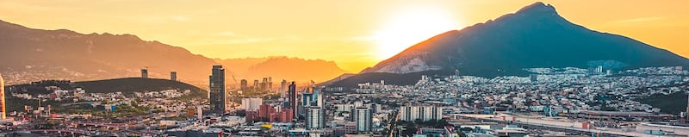

Arrival at the international airport of Monterrey Reception and transfer to your hotel.

Check in at hotel. Rest of the day at leisure.

Lunch and dinner at leisure. Lodging

DAY 02 – MONTERREY– City Tour

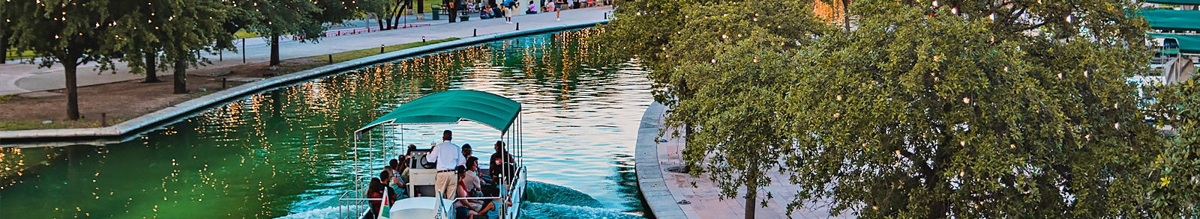

Breakfast at the hotel.

We will start at the Cathedral of Monterrey, then we will visit the Municipal Government Palace, we will visit the San Miguel Arcangel Bridge, the Hidalgo Square, we will also pass by the Nuevo Leon Artisans Market, where you will find regional sweets such as the delicious glories, also the Fountain of Life, the Esplanade of the Heroes, among other points. We will see different monuments along the Macro Plaza, which is considered the 5th largest square in the world. We will continue to the Government Palace Museum, a quarry building over 100 years old, where we will learn about the history of the city. Then we will witness the place where the origin and foundation of the city took place, the springs of Santa Lucia that to date have been transformed into a navigable canal considered one of the 13 wonders created by man, and is known as Paseo Santa Lucia. We will board a boat that will take us to the emblematic Fundidora Park, a space of nature, tradition and culture where we will discover why it is an invaluable part of our Industrial Heritage, being one of the main lungs of Monterrey.

Lunch and dinner at leisure. Lodging

DAY 03 – MONTERREY – Cola de Caballo

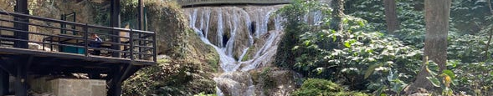

Breakfast at the hotel.

In Villa de Santiago, named Magical Town since 2006, is distinguished by its beautiful landscapes, sheltered by the Sierra Madre Oriental; This beautiful town surrounded by beautiful mountains of dense pine-oak forests, where we will visit the most famous waterfall in the state of Nuevo Leon, the Cascada Cola de Caballo, which is located within the state park of the same name, in addition to the waterfall we will find beautiful handicrafts, and extra activities (NOT included) Continue to the historic center of Santiago, where we can appreciate the traditional colonial architecture of the region. Finally, we will make a stop at a typical mill where you will find regional sweets, corn bread, glorias, dried meat, snow and more typical delicacies.

Lunch and dinner at leisure. Lodging

DAY 04 – MONTERREY – Grutas de Garcia (Tuesday to Sunday)

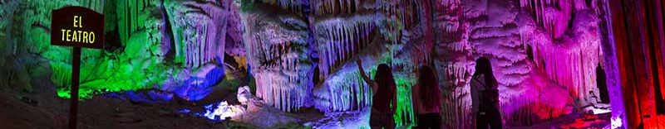

Breakfast at the hotel.

The Caves of Garcia is one of the most visited attractions of Nuevo Leon, located in the municipality of Garcia, in this tour you can admire the different formations of stalactites and stalagmites in a tour of more than 45 minutes inside, also we will climb more than 200 meters in the cable car. Inside the caves we will find some impressive balconies where we will observe the formations that are millions of years old and some of them are still growing. We will see some formations such as El Mirador de la Mano, Salón del Aire, La Octava Maravilla, El Nacimiento, La Fuente Congelada, La Torre China, El Teatro and El Árbol de Navidad among others. We will finish in the historic center to enjoy the non-restored architecture that characterizes this municipality.

Lunch and dinner at leisure. Lodging

DAY 05 – MONTERREY / OUT

Breakfast at the hotel.

At a convenient time transfer from your hotel to the airport to take the flight to your destination.

END OF SERVICES
NOTE: The day of operation of the tours may vary.
** VALIDATE RATES WITH YOUR TRAVEL AGENT

CITY | NIGHTS | HOTELS 4*
Monterrey | 04 | NH Collection Monterrey San Pedro

INCLUDED:
- TRANSPORTATION: Air-conditioned touristic unit
- ACCOMMODATION: Hotels according to your choice
- MEALS: 04 Breakfast
- VISITS: Those mentioned in the program.
- ESCORT GUIDE: Bilingual, certified by the Ministry of Tourism
NOT INCLUDED:

- Air tickets
- Food or services not mentioned
- Taxes at the airport
- Tips to guides or drivers.

IMPORTANT OBSERVATIONS:
- Due to the multiple changes that occur daily in tourism, these prices must be confirmed at the time of requesting the reservation.
- Rates subject to availability and changes without prior notice.
- Credit card payments are subject to a % commission.
- Please contemplate the schedule of Check in 15:00 hrs and Check Out 12:00 hrs.
- TRIPLE rooms only have 2 double beds.
- Transfers airport-hotel-airport are quoted in shared service, please consider flights arriving and departing between 06:00 and 22:00 hrs, otherwise it must be provided in private service and it will be necessary to re-quote.
- The waiting time for arrival transfers is 2 hours and 15 minutes. Once this time has elapsed, the passenger must transfer at his/her own expense.
- The tolerance time for departure transfer is 10 minutes, after this time the unit is withdrawn and you must transfer on your own to the apartment. * Under no circumstances will we be responsible for any extra expenses arising from this situation.
- Tours may change order according to the operations of the correspondent

