PROGRAM
AGUASCALIENTES CULTURAL
05 days/04 nights

(Ciudad, San Jose de Gracia, Calvillo)

Minimum 2 persons.
Daily Departures

ITINERARY

DAY 01 – IN / AGUASCALIENTES
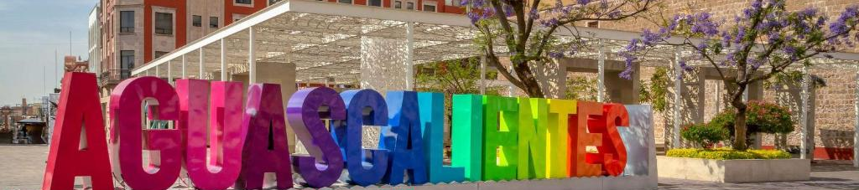
Arrival at Aguascalientes International Airport. Reception and transfer to your hotel.
Check in at hotel. Rest of the day at leisure.
Lunch and dinner at leisure. Lodging

DAY 02 – AGUASCALIENTES – San José de Gracia

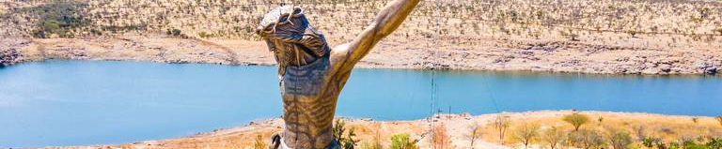

Breakfast at the hotel.

We will board a small boat to cross the "Calles" dam where the sanctuary of the CRISTO ROTO is located with its 28 meters high, listen to its history and visit the 24 niches that contain the replicas of the most representative Christs of the State of Aguascalientes, when we return we will board again our transportation to go to El Mirador with a splendid view, we will take pictures and if you feel like having a drink (not included), then to finish our tour; we will arrive at the local vineyard to make a small tour of the facilities and taste their delicious wines.

Lunch and dinner on your own. Lodging.

DAY 03 – AGUASCALIENTES – Visita de Ciudad

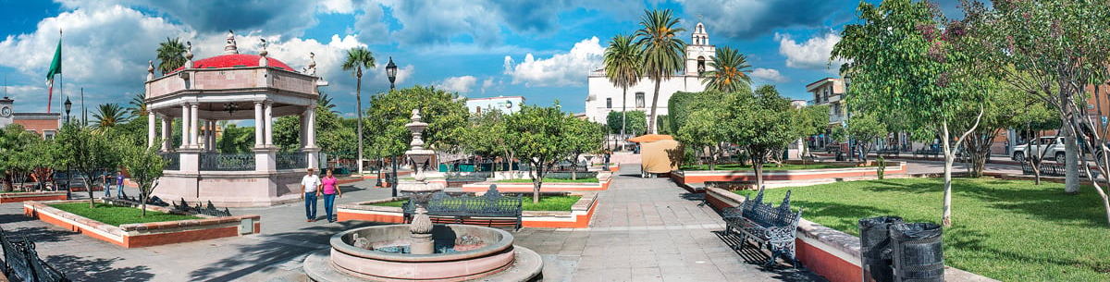

Breakfast at the hotel.

Join us to get to know our beautiful city through its 4 main neighborhoods... San Marcos (perimeter of the famous National Fair of San Marcos), Guadalupe and its beautiful Baroque style temple, Triana (El Encino) Spanish neighborhood with bullfighting tradition par excellence and finally the neighborhood of the Station (Old Locomotive Workshops) We visit some sites of interest such as the Island of San Marcos, the Cerro del Muerto and the Museum of Guadalupe Posada (creator of the Catrina), is a tour where you go knowing the history, legends and traditions of these sites and take pictures.

Lunch and dinner on your own. Lodging.

DAY 04 – AGUASCALIENTES – Calvillo



Breakfast at the hotel.

Visit the company dedicated to the production of handmade guava candy with its respective tasting of products, visit the National Museum of Magical Towns that was awarded to Calvillo because it is one of the fastest growing magical towns, at the end we will tour the main square of this beautiful magical town in which we will taste a delicious traditional snow, visit workshops or stores of local crafts such as embroidered or unraveled garments, jewelry, organic, mining, among others. Taste its traditional bread, sweets and cheese.

Lunch and dinner on your own. Lodging.

DAY 05 – AGUASCALIENTES / OUT

Breakfast at the hotel.

At a convenient time transfer from your hotel to the airport to take your flight to your destination.

END of SERVICES

NOTE: The day of operation of the tours may vary.
** VALIDATE RATES WITH YOUR TRAVEL AGENT

CITY | NIGHTS | HOTELS 3* | HOTELS 4*
Aguascalientes | 04 | Misión Aguascalientes | Holiday Inn Aguascalientes
- No app Feria de San Marcos ni Holy Week
INCLUDED:
- TRANSPORTATION: Air-conditioned touristic unit
- ACCOMMODATION: Hotels according to your choice
- MEALS: 04 Breakfast at Hotel
- VISITS: Those mentioned in the program.
- ESCORT GUIDE: Bilingual, certified by the Ministry of Tourism
NOT INCLUDED:

- Air tickets
- Food or services not mentioned
- Taxes at the airport
- Tips to guides or drivers.

IMPORTANT OBSERVATIONS:
- Due to the multiple changes that occur daily in tourism, these prices must be confirmed at the time of requesting the reservation.
- Rates subject to availability and changes without prior notice.
- Credit card payments are subject to a % commission.
- Please contemplate the schedule of Check in 15:00 hrs and Check Out 12:00 hrs.
- TRIPLE rooms only have 2 double beds.
- Transfers airport-hotel-airport are quoted in shared service, please consider flights arriving and departing between 06:00 and 22:00 hrs, otherwise it must be provided in private service and it will be necessary to re-quote.
- The waiting time for arrival transfers is 2 hours and 15 minutes. Once this time has elapsed, the passenger must transfer at his/her own expense.
- The tolerance time for departure transfer is 10 minutes, after this time the unit is withdrawn and you must transfer on your own to the apartment. * Under no circumstances will we be responsible for any extra expenses arising from this situation.
- Tours may change order according to the operations of the correspondent.

