PROGRAM

CHIAPAS… COLOR FAN
05 days/04 nights

(Tuxtla Gutierrez, Cañón del Sumidero, Agua Azul, Chamula, Zinacatan, Palenque)

Minimum 2 persons.
Daily Departures

ITINERARY

DAY 01 – IN / TUXTLA GUTIERREZ – Cañon del Sumidero + Chiapa de Corzo – SAN CRISTOBAL DE LAS CASAS

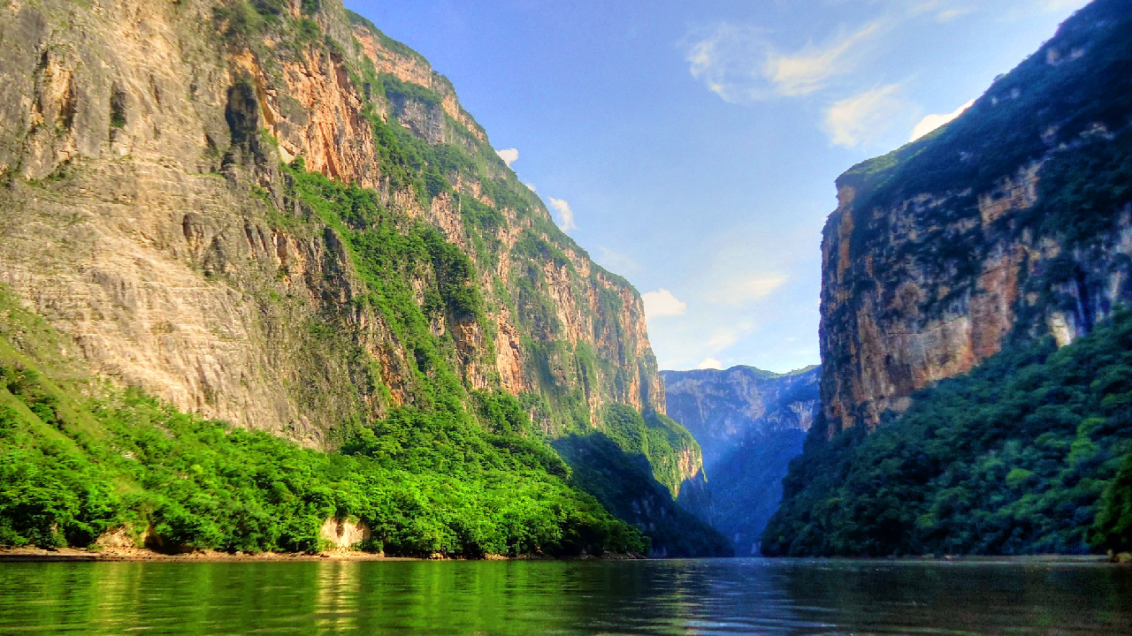Arrival at Tuxtla airport before 13:00 hours.

Transfer to the pier for a boat tour of the CAÑON DEL SUMIDERO, one of the most spectacular nature reserves in Mexico, it is a geological fault formed 36 million years ago, with limestone walls that rise to more than 1000 meters. At the end of the tour we will visit CHIAPA DE CORZO, a city that was the first settlement founded by the Spaniards with its Mudejar fountain, better known as "La Pila", it was built in the XVI century and is a great example of colonial architecture with a marked Spanish-Arabic influence. Continuation to San Cristobal de las Casas.

Check in at the hotel. Rest of the day at leisure.
Lunch and dinner on your own.
Lodging.

DAY 02 – SAN CRISTOBAL DE LAS CASAS – Chamula + Zinacatan

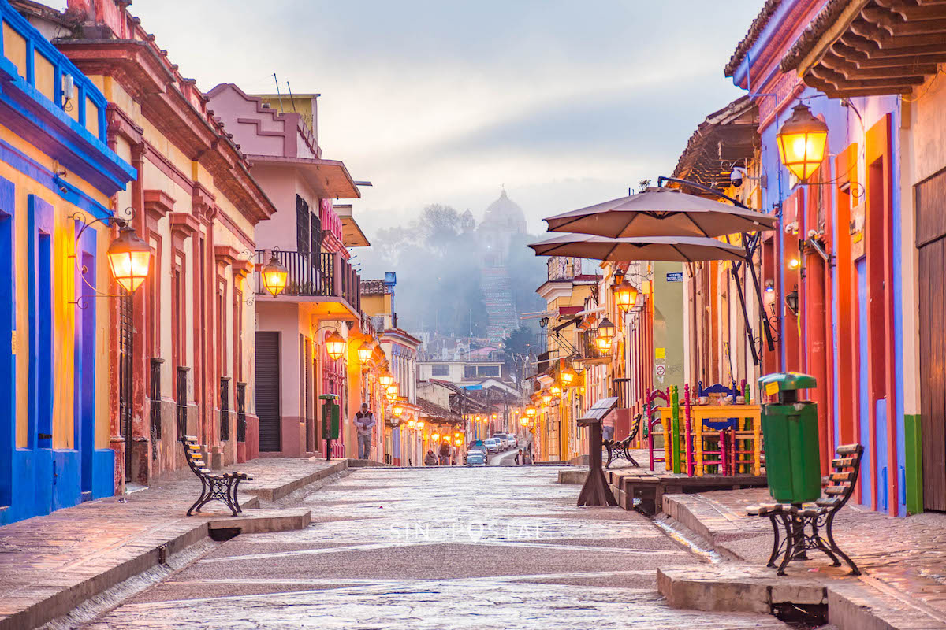
Breakfast at the hotel.

We will visit San Juan Chamula and Zinacantán, indigenous communities that still preserve their language, traditions, religious beliefs and social organization. It is essential to visit their churches, their homes and their clothing to get an idea of the love these people have for their culture. On the way back to San Cristobal, we will visit the Typical Market, Santo Domingo, the Cathedral. Rest of the afternoon at leisure. We recommend a visit to the Jade Museum, where there is a copy of the Tomb of King Pakal.

Lunch and dinner on your own.
Lodging.

DAY 03 – SAN CRISTOBAL DE LAS CASAS – Agua Azul - Misol Ha – PALENQUE

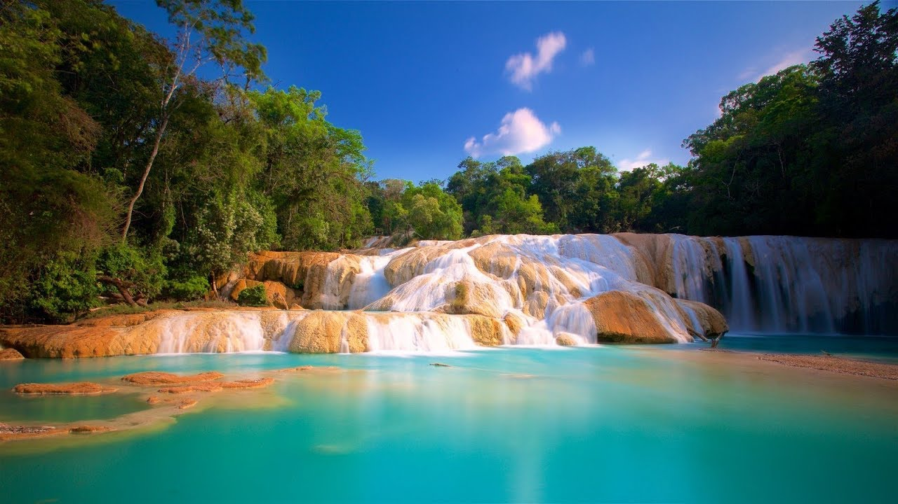

Breakfast at the hotel.

Departure at 06:00 hours from the hotel to Palenque, on the way we will make a technical stop before arriving in Ocosingo, then we will visit the Cascadas de Agua Azul set of rapids, falls and backwaters of a tributary of the Tulijá River, captivates the beauty of the river, its brightness and intense turquoise color. Transfer to your hotel in Palenque.

Check in at the hotel.
Lunch and dinner on your own.
Lodging.

DAY 04 – PALENQUE – Bonampak + Yaxchilan

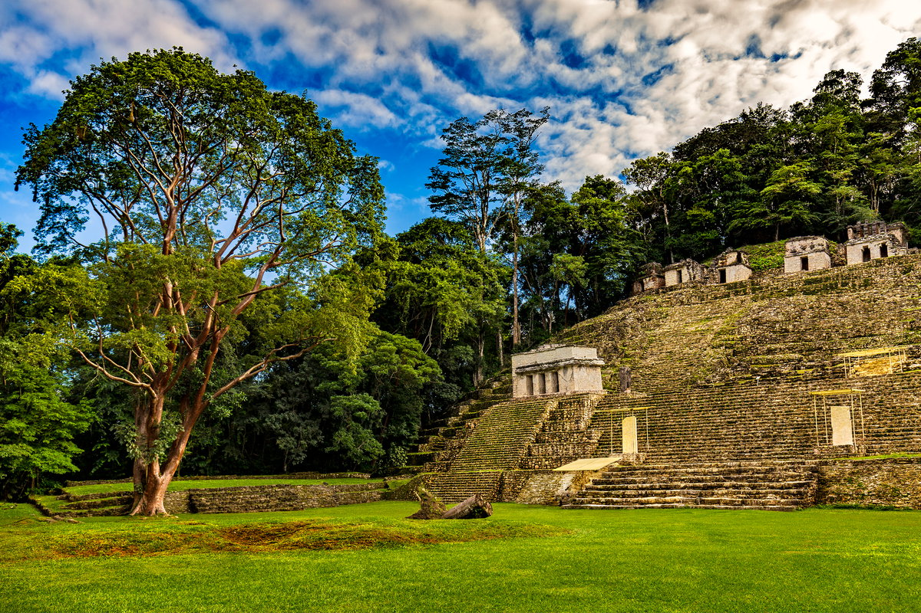

Breakfast at the hotel.

In the morning departure to visit the archaeological site of Bonampak in the Montes Azules reserve accompanied by an indigenous Lacandon guide. Later, transfer to Frontera Corozal to board a boat and arrive at the Yaxchilan archaeological site located on the banks of the Usumacinta River. Return to Frontera Corozal and free time for lunch at a typical local restaurant. Return to the hotel in Palenque.

Lunch and dinner on your own.
Lodging.

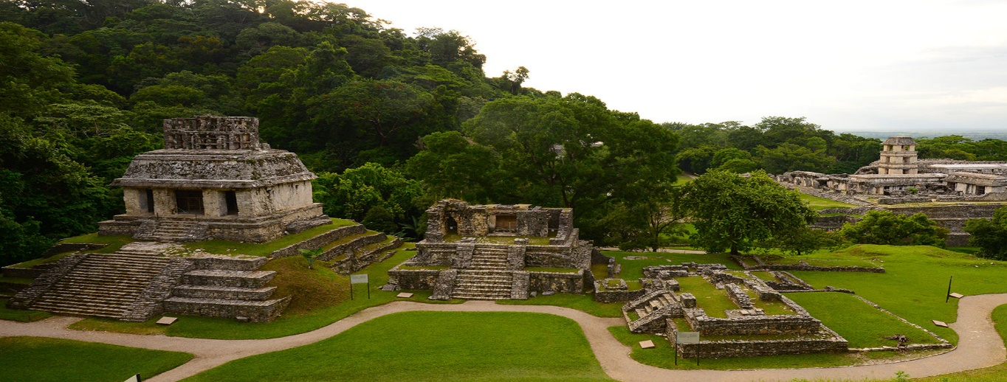
DAY 05 – PALENQUE – VILLAHERMOSA

Breakfast at the hotel.

Visit to the Archaeological Zone of Palenque, one of the most remarkable Mayan cities for its beautiful sculptural art and its important architecture in the middle of the green jungle. Transfer to Villahermosa airport at approximately 17:00 hours.

END OF SERVICES

** VALIDATE RATES WITH YOUR TRAVEL AGENT

CITY | NIGHTS | HOTELS 3** | HOTELS 4*
San Cristóbal de las Casas | 02 | Junvay | Mansión de Valle
Palenque | 02 | Nututun | Chan Kah

INCLUDED:
- TRANSPORTATION: Air-conditioned touristic unit
- ACCOMMODATION: Hotels according to your choice
- MEALS: 04 Breakfast
- VISITS: Those mentioned in the program.
- ESCORT GUIDE: Bilingual, certified by the Ministry of Tourism
NOT INCLUDED:

- Air tickets
- Food or services not mentioned
- Taxes at the airport
- Tips to guides or drivers.

IMPORTANT OBSERVATIONS:
- Due to the multiple changes that occur daily in tourism, these prices must be confirmed at the time of requesting the reservation.
- Rates subject to availability and changes without prior notice.
- Credit card payments are subject to a % commission.
- Please contemplate the schedule of Check in 15:00 hrs and Check Out 12:00 hrs.
- TRIPLE rooms only have 2 double beds.
- Transfers airport-hotel-airport are quoted in shared service, please consider flights arriving and departing between 06:00 and 22:00 hrs, otherwise it must be provided in private service and it will be necessary to re-quote.
- The waiting time for arrival transfers is 2 hours and 15 minutes. Once this time has elapsed, the passenger must transfer at his/her own expense.
- The tolerance time for departure transfer is 10 minutes, after this time the unit is withdrawn and you must transfer on your own to the apartment. * Under no circumstances will we be responsible for any extra expenses arising from this situation.
- Tours may change order according to the operations of the correspondent.

