PROGRAM
PROGRAM 4
08 days/07 nights

(City, Basilica of Guadalupe, Pyramids of Teotihuacán, Taxco, Puebla, Tonantzintla, Xochimilco, Coyoacán)

Minimum 2 persons.
Daily Departures

ITINERARY

DAY 01 – IN / CIUDAD DE MÉXICO

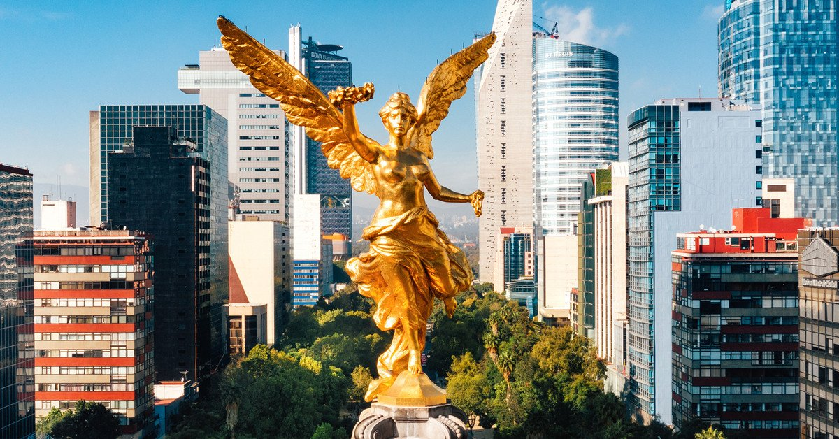
Arrival at the international airport in Mexico City. Reception and transfer to your hotel.

Check in at the hotel. Rest of the day at leisure.

Lunch and dinner at leisure. Lodging

DAY 02 – CIUDAD DE MÉXICO – City Tour

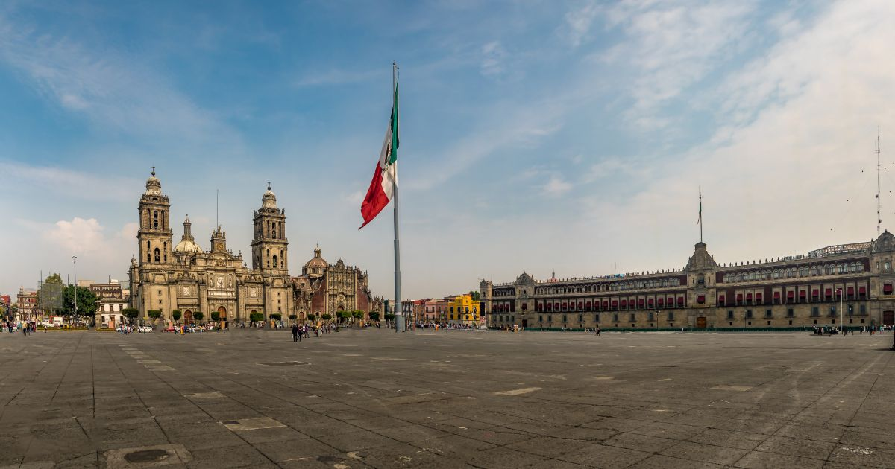

Breakfast at the hotel.

We will visit the Zocalo, the National Palace (outside view). We will see the ruins of what was the Templo Mayor of the Aztecs and the Metropolitan Cathedral. We will take you to the historic Chapultepec forest surrounded by residential areas such as Las Lomas; where you will see the residences of famous artists.

Lunch and dinner at leisure. Lodging

DAY 03 – CIUDAD DE MÉXICO – Basílica + Pyramids

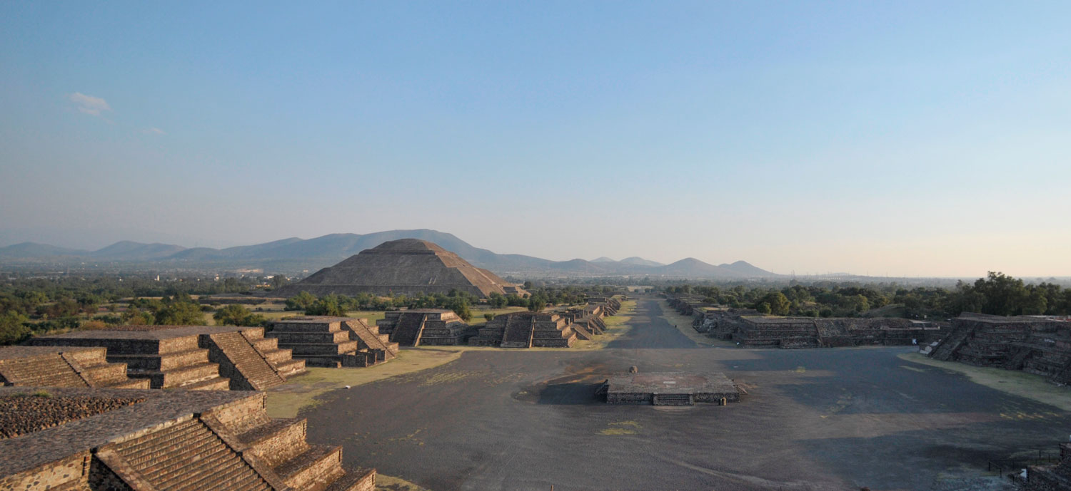

Breakfast at the hotel.

Panoramic visit to the Plaza de las Tres Culturas; historical site where the last fight between Aztecs and Spaniards was fought and which symbolizes the fusion of 3 cultural eras represented by the Aztec ruins; the church of Tlatelolco and the building of the Ministry of Foreign Affairs. After a short stop, we will continue to the Basilica of Guadalupe, where we will see the original image of the Virgin of Guadalupe. You will learn the story of how she was captured on the mantle of the native Juan Diego and see the ancient basilica at the foot of the Tepeyac hill. By a modern highway we will go directly to the archaeological zone of Teotihuacan; the city of the gods; 50 km away where we will be able to admire the impressive pyramids of the sun and the moon; walk along the avenue of the dead; we will visit an obsidian workshop for the demonstration of obsidian and maguey.

Lunch and dinner on your own. Lodging

DAY 04 – CIUDAD DE MÉXICO – Cuernavaca + Taxco

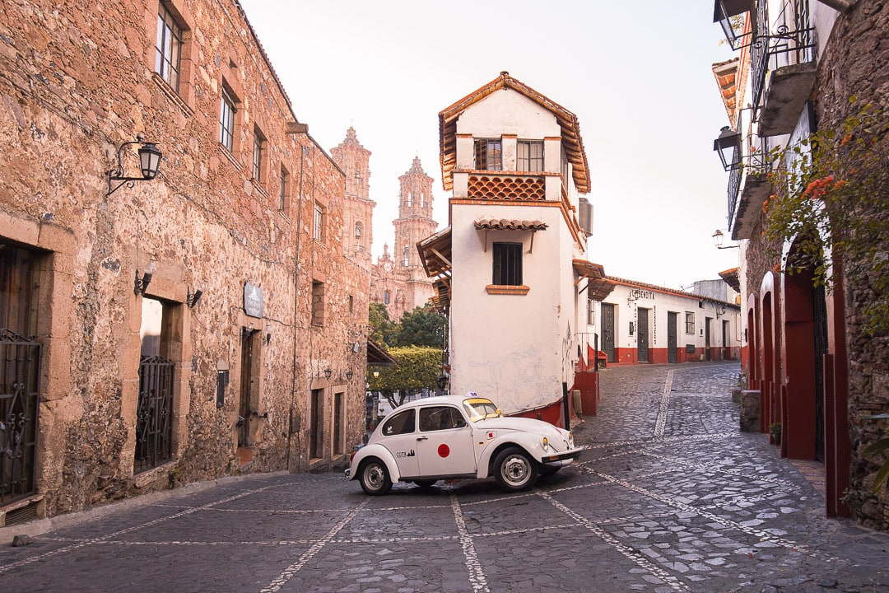

Breakfast at the hotel.

Departure in the morning to Cuernavaca from the south of the city and continue along the modern highway that in approximately 1 hour will take us to the city of the bougainvilleas or the eternal spring; because of its warm climate. We will visit the cathedral which was built as a mission in 1552 and in 1891 was elevated to a cathedral (representative of the viceroyalty period). We will continue our journey along winding roads through the mountain range of the Sierra Madre Occidental; flanked by valleys and pine forests and we will enter the highlands of the state of Guerrero until we reach the picturesque colonial mining town of Taxco; known as the city of silver. We will visit the famous church of Santa Prisca. It is said to have been built with silver from Taxco. Time to visit its silversmiths' shops walking through its cobbled squares and narrow streets framed by rustic and picturesque houses of reddish tiles that have been the inspiration for countless artists. Return to the hotel at approximately 20:00 hours.

Lunch and dinner on your own. Lodging

DAY 05 – CIUDAD DE MÉXICO – Cholula + Puebla

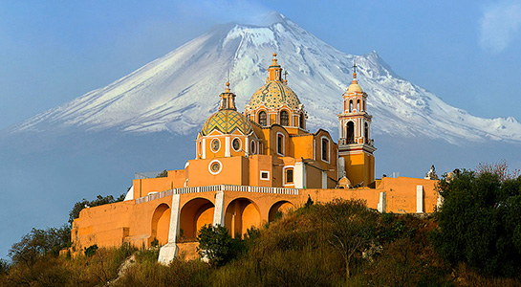

Breakfast at the hotel.

We will leave the city towards the state of Puebla, first we will visit the pyramid of Cholula and the Church of Nuestra Señora de los Remedios, which technically is located on the top of the hill where the pyramid was erected. Then we will visit the Church of Santa Maria Tonantzintla, a place that at first glance seems to have nothing special about it, but its beautiful decoration leaves any visitor astonished. We will move on to the Chapel of the Rosary, a masterpiece of baroque architecture and decoration where we will be able to enjoy a mass in this wonderful religious space. We will finish this wonderful day of sightseeing at the Cathedral of Puebla de los Angeles. Return to Mexico

Lunch and dinner at leisure. Lodging

DAY 06 – CIUDAD DE MÉXICO – Xochimilco + Coyoacan + Museo de Frida Kahlo

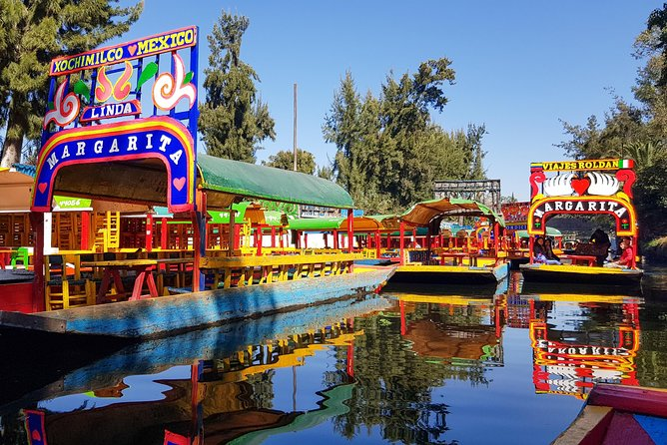

Breakfast at the hotel.

We will cross the city to get to Xochimilco to take a boat that will take us through the canals of Xochimilco in a trajinera. Later we will visit the former town of Coyoacan, which is now part of the big city of Mexico and fascinates with its colonial architecture and colourful heritage. Continue to the Frida Kahlo museum; the house where the artist lived with her husband Diego Rivera. Free time to walk around the Hidalgo square and enjoy the cafes or visit the popular market of this neighbourhood.

Lunch and dinner at leisure. Lodging

DAY 07 – CIUDAD DE MÉXICO
Breakfast at the hotel.

Free day for personal activities and enjoy the city.

Lunch and dinner at leisure. Lodging.

DAY 08 – CIUDAD DE MÉXICO / OUT

Breakfast at the hotel.

At a convenient time transfer from your hotel to the airport to take your flight to your destination.

END of SERVICES

CITY | NIGHTS | HOTELS 3** | HOTELS 4* | HOTELS 4**
Ciudad de México | 07 | Premier / Regente / Estoril | Casa Blanca / PF / Royal Reforma | Laila / Galería Plaza

INCLUDED:
- TRANSPORTATION: Air-conditioned touristic unit
- ACCOMMODATION: Hotels according to your choice
- MEALS: Daily Breakfast
- VISITS: Those mentioned in the program.
- ESCORT GUIDE: Bilingual, certified by the Ministry of Tourism

NOT INCLUDED:

- Air tickets
- Food or services not mentioned
- Taxes at the airport
- Tips to guides or drivers.

IMPORTANT OBSERVATIONS:
- Rates subject to availability and subject to change without notice.
- Credit card payments are subject to a % commission.
- If flights arrive or depart from and to the new Felipe Angeles airport, a supplement will be charged.
- Please consider the check in time 15:00 hrs and check out time 12:00 hrs.
- The waiting time for arrival transfers is 2 hours and 15 minutes. Once this time has elapsed, the passenger will have to transfer at his/her own expense.
- The tolerance time for departure transfer is 10 minutes, after this time the unit is withdrawn and you will have to transfer to the apartment on your own. * Under no circumstances will we be responsible for any extra expenses that may arise from this situation.
- We will NOT be able to provide services if a previous reservation is not made 7 days before the tour starts.
- Tours may change order depending on the operations of the correspondent.

