CIRCUIT
POR EL CORAZÓN DE MÉXICO
11 days/10 nights

(Mexico City, Museum of Anthropology, Plaza of the Three Cultures, Teotihuacan Pyramids, Guadalupe Shrine, Querétaro, San Miguel de Allende, Guanajuato, Zacatecas, Guadalajara, Tlaquepaque, Tequila, Pátzcuaro y Morelia)

Minimum 2 persons.
02 Monthly Departures

Departure’s date 2026:

JANUARY | 05 y 19 | JULY | 20
FEBRUARY | 02 y 16 | AUGUST | 03 y 17
MARCH | 02 y 16 | SEPTEMBER | 07 y 21
APRIL | 06 y 20 | OCTOBER | 05
MAY | 04 y 18 | NOVEMBER | 16
JUNE | NOT APPLICABLE | DECEMBER | 07 y 14

** Ask your executive if there are more persons signed up on the date you are interested in.

ITINERARY

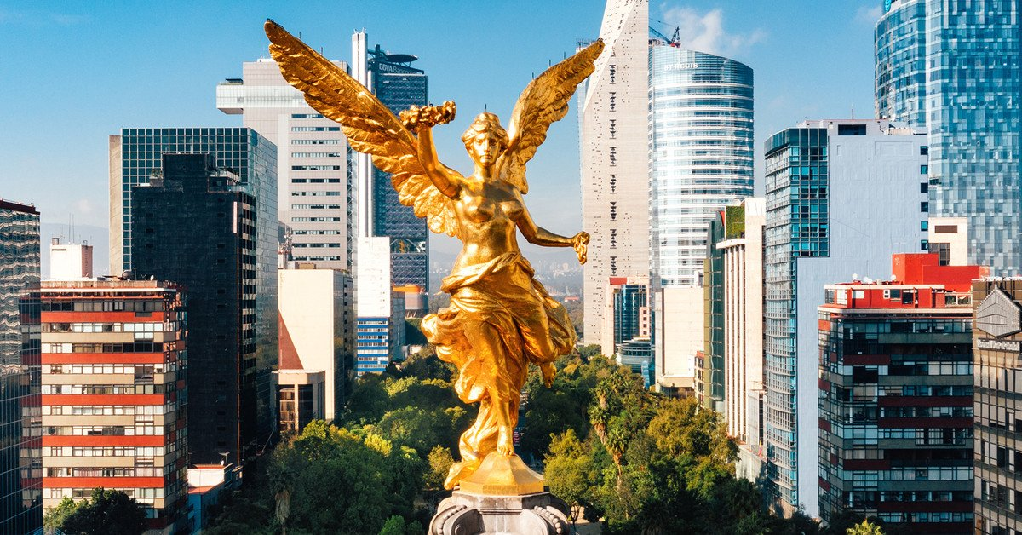
DAY 01 (Monday) – IN / MEXICO CITY

Arrival at Mexico City International Airport. Reception and transfer to your hotel.

Check in at hotel. Rest of the day free.

Lunch and dinner on your own. Lodging

DAY 02 (Tuesday) – MEXICO CITY – Guadalupe Shrine + Teotihuacan Pyramids Guadalupe Shrine

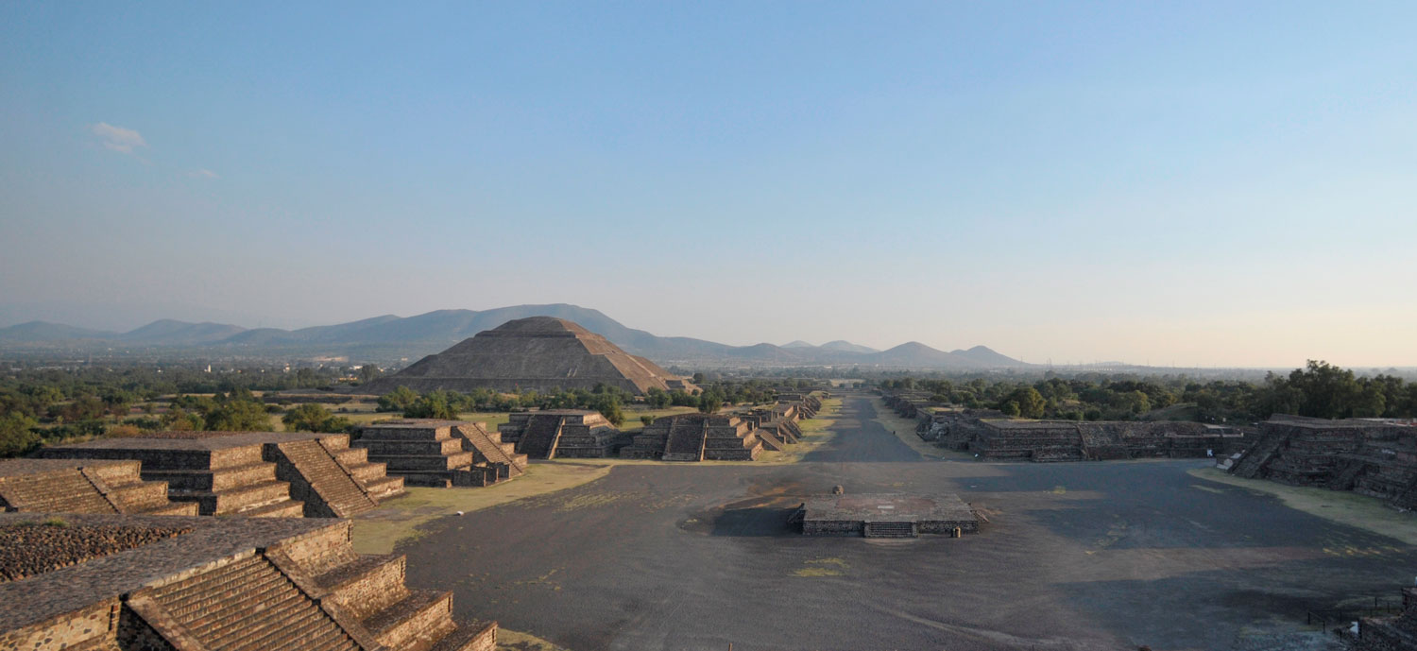
Breakfast at the hotel.

Panoramic visit to the Plaza de las Tres Culturas; historical site where the last fight between Aztecs and Spaniards was fought and which symbolizes the fusion of 3 cultural eras represented by the Aztec ruins; the church of Tlatelolco and the building of the Ministry of Foreign Affairs. We will continue to the Basilica of Guadalupe, where we will see the original image of the Virgin of Guadalupe. You will learn the story of how it was captured in the mantle of the indigenous Juan Diego and see the ancient basilica at the foot of the Tepeyac hill. By a modern highway we will go directly to the archaeological zone of Teotihuacan; the city of the gods; 50 km away where we can admire the impressive pyramids of the sun and the moon; walk along the avenue of the dead, we will visit an obsidian workshop for the demonstration of obsidian and maguey. Buffet lunch (without drinks).

Dinner on your own. Lodging.

DAY 03 (Wednesday) – MEXICO CITY – City tour + Museum of Anthropology

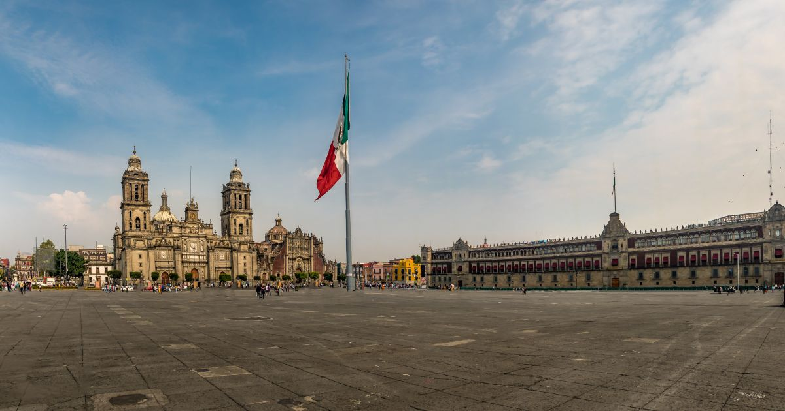
Breakfast at the hotel.
Visit the Zocalo, the National Palace and panoramic view. We will see the ruins of what was the Templo Mayor of the Aztecs and the Metropolitan Cathedral. We will take you to the historic Chapultepec forest surrounded by residential areas such as Las Lomas, where you will see the residences of famous artists. Visit the National Museum of Anthropology, where you will appreciate a mosaic of the most important cultures of the country. You can stay at the museum to visit it completely or be transferred to your hotel.
Lunch and dinner on your own. Lodging.

DAY 04 (Thursday) – MEXICO CITY – Queretaro – SAN MIGUEL DE ALLENDE

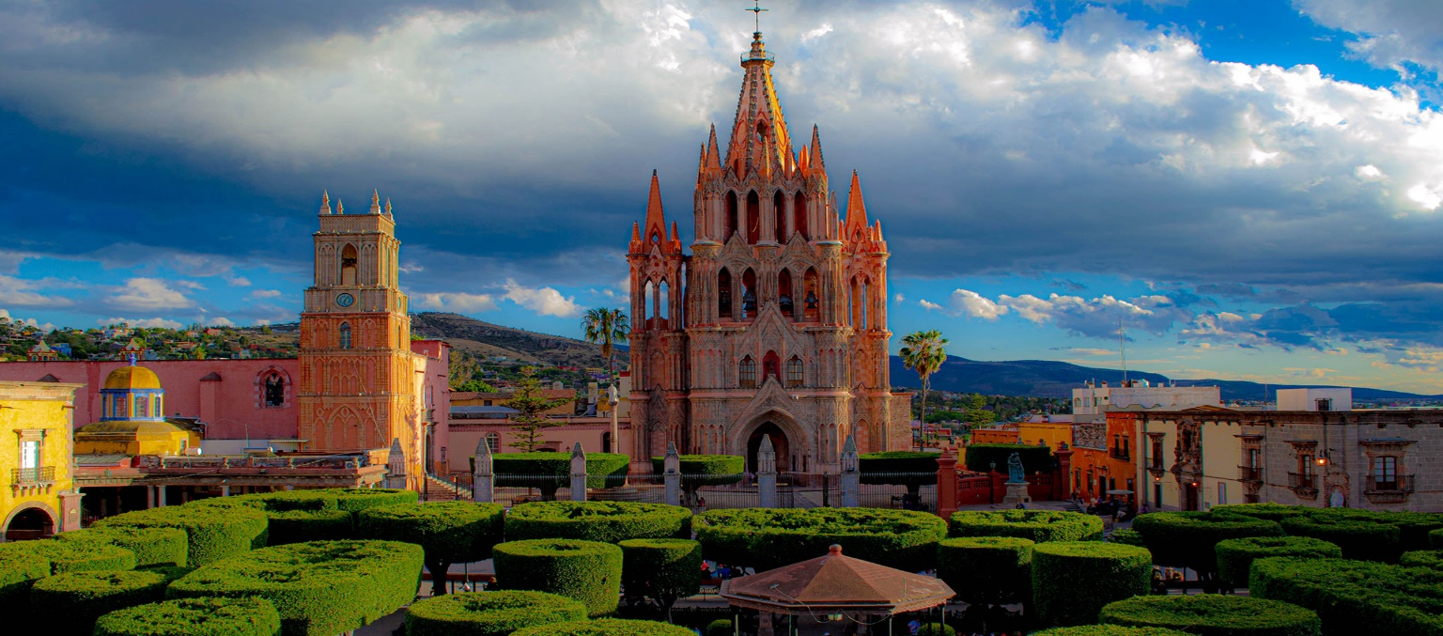
Breakfast at the hotel.

Departure to Queretaro, a World Heritage City, where we will visit the Aqueduct, the Ex-Convent of the Cross and the Historic Center. Continue to San Miguel de Allende. Afternoon to visit this peaceful city where the great comedian Mario Moreno “Cantinflas” lived and a place of residence for artists and intellectuals. Highlights include the Parish of San Miguel Arcangel, the Chapel of the Holy House, the Convent of the Conception, the Church of San Francisco and the Allende House and Institute. You will find a variety of cafes and restaurants to choose from.

Check in at the hotel
Lunch and dinner on your own. Lodging.

DAY 05 (Friday) – SAN MIGUEL DE ALLENDE – Dolores Hidalgo – GUANAJUATO

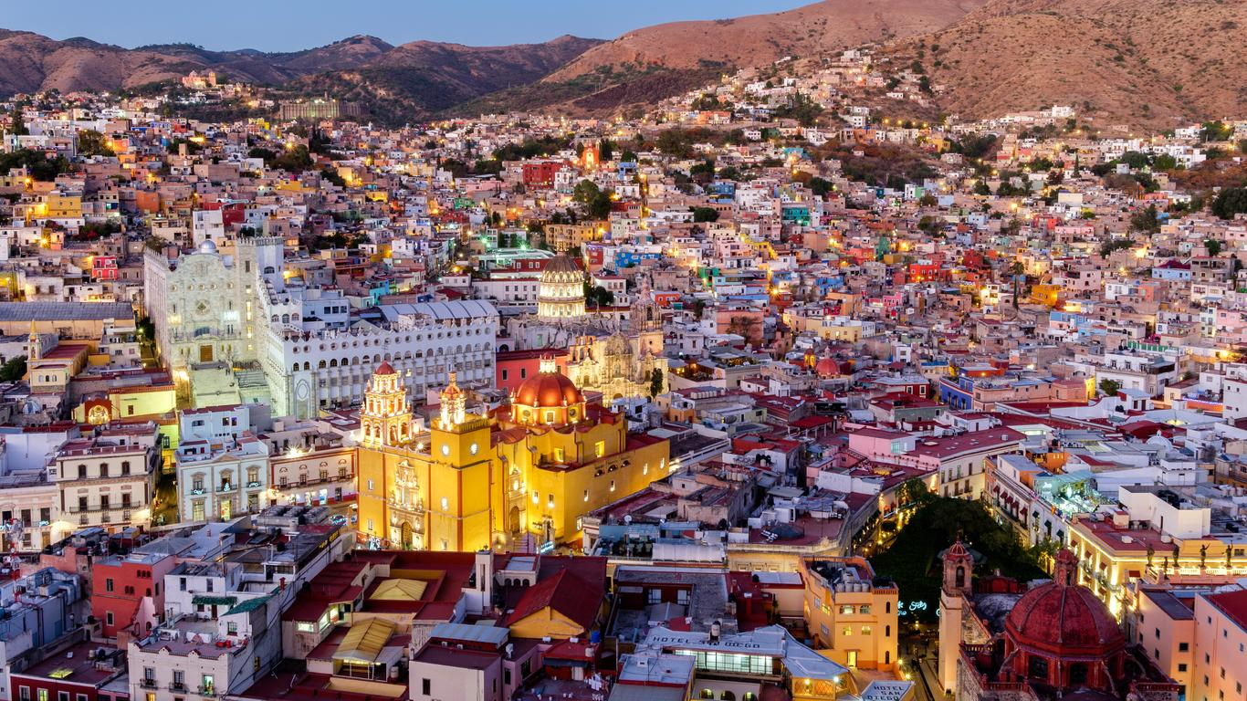
Breakfast at the hotel.

Departure to Dolores Hidalgo, where the priest Don Miguel Hidalgo gave the “Cry of Independence” of Mexico in 1810. There we will find the house-museum of this national hero. We will continue to Guanajuato, a World Heritage City, home of the annual Cervantino International Festival. In the afternoon we will enjoy this beautiful city, full of alleys and squares, which offers us very interesting places such as the University, the Juarez Theater, the Kiss Alley, the house-museum of the muralist Diego Rivera, husband of Frida Kahlo. Its streets and subway avenues are unique in the country. Other attractive options are: the “callejoneada” accompanied by a musical estudiantina or tuna valenciana, the house of Jorge Negrete, the museum of Don Quijote y las Momias.

Check in at the hotel
Lunch and dinner on your own. Lodging.

DAY 06 (Saturday) – GUANAJUATO – ZACATECAS

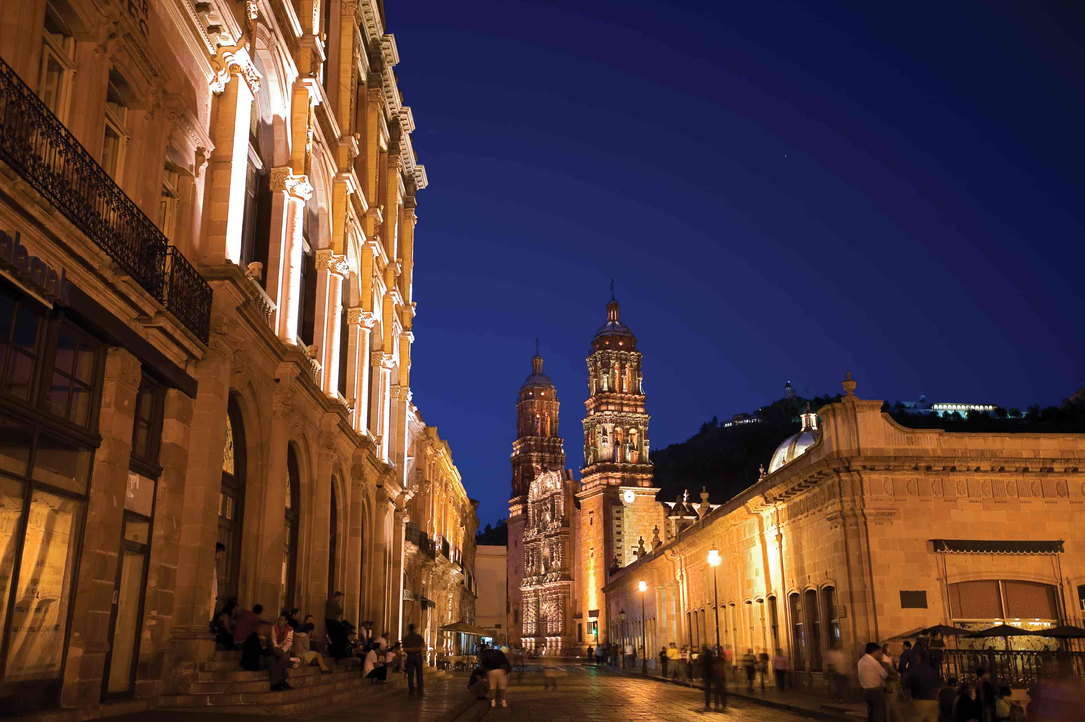
Breakfast at the hotel.

Departure to Zacatecas, beautiful mining city declared a World Heritage Site, beautiful facades carved in pink quarry, whose cathedral is the most outstanding example of Mexican baroque. Panoramic view of the city from the Cerro de la Bufa, descent by cable car and educational visit to the Eden Mine. Possibility of witnessing a musical “callejoneada” with Tambora. Other attractive options in the city are the Rafael and Pedro Coronel and Francisco Goitia museums.

Check in at the hotel
Lunch and dinner on your own. Lodging.

DAY 07 (Sunday) – ZACATECAS – GUADALAJARA

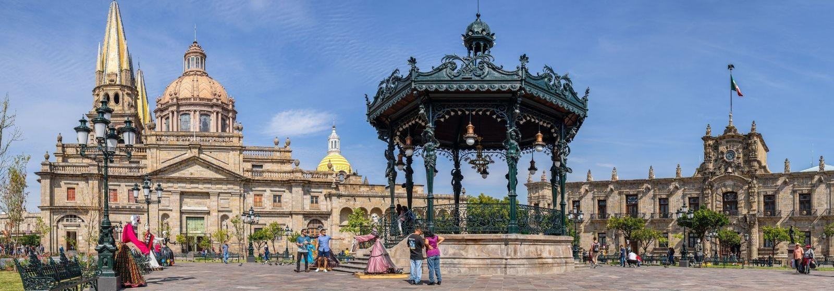
Breakfast at the hotel.

Departure to the city of Guadalajara, birthplace of Mariachi and Tequila, which distinguish Mexico in the world. Visit the district of Tlaquepaque famous for making the finest handicrafts in the state. Here you will find the famous gallery of Sergio Bustamante. Possibility to have lunch in one of the typical restaurants accompanied by a mariachi band.

Check in at the hotel
Lunch and dinner on your own. Lodging.

DAY 08 (Monday) – GUADALAJARA – Tequila

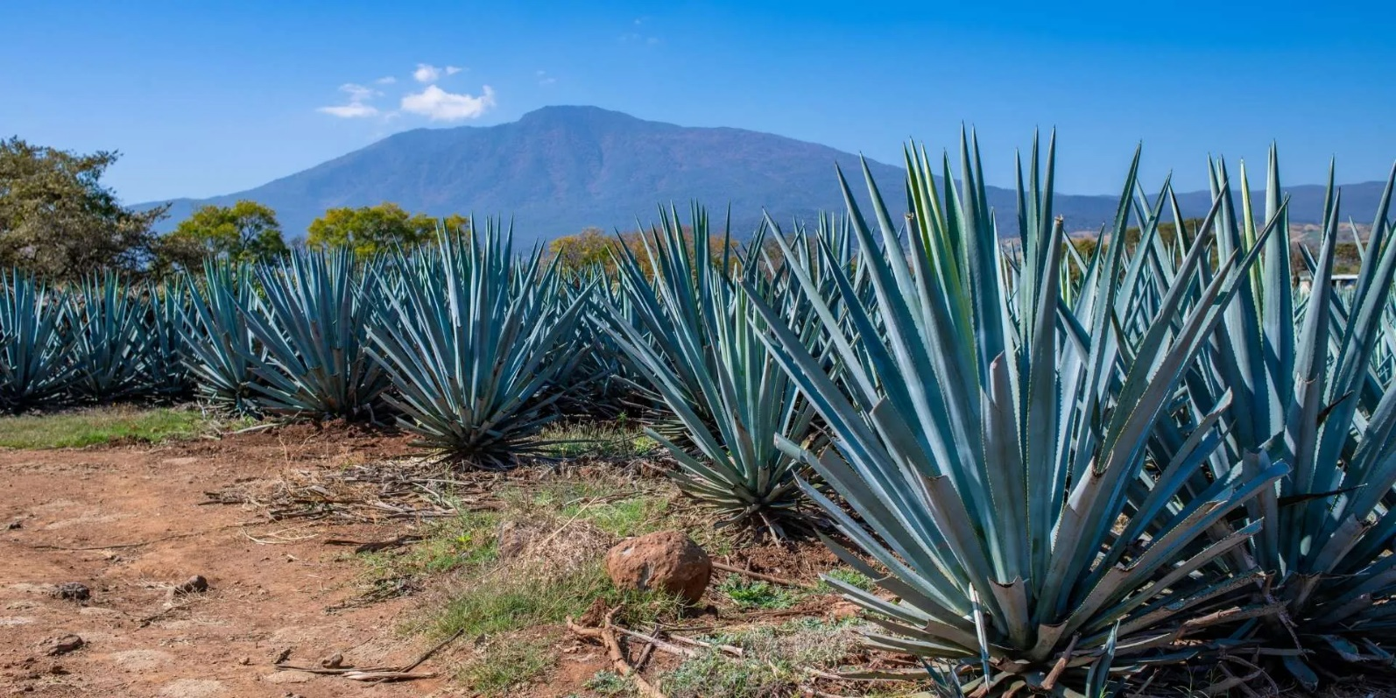
Breakfast at the hotel.

In the morning we will visit the city where we will observe points of interest such as the teatro degollado, the cathedral, the rotunda of illustrious men, the government palace that houses splendid murals by Orozco, the plaza tapatía and a panoramic view of the hospicio cabañas. We continue to Tequila, a typical town where the main distilleries of this world-renowned liquor are located. We will visit the agave fields, the plant from which the “jimadores” extract the pineapple to obtain tequila. We will visit a distillery to learn in detail the production process of this drink. Return to Guadalajara.

Lunch and dinner on your own. Lodging.

DAY 09 (Tuesday) – GUADALAJARA – Rancho Los 3 Potrillos - Patzcuaro - MORELIA

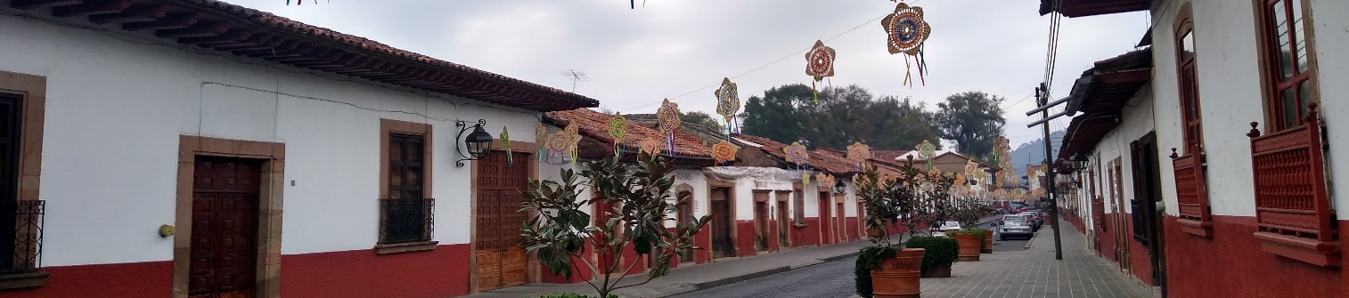
Breakfast at the hotel.

We will be on the road again and visit Vicente Fernandez's ranch, Los Tres Potrillos, as far as his guards allow it since it is a private property; we will visit his store considered “the biggest cowboy store in the world”.
Continuation to Patzcuaro, which means “the door to heaven” in the Purépecha language. This city is famous for its colonial beauty, original customs and local population. Among its attractions are the miraculous Basilica of Our Lady of Health, the “House of the Eleven Patios”, the historic center with its squares Vasco de Quiroga and Gertrudis Bocanegra. Continue to Morelia, the city of light with the best illuminated historic center in Mexico. Optionally you can listen to the legendary routes of the Colonial era. In the portals of downtown, you can enjoy a variety of cafes and restaurants with typical dishes.

Check in at the hotel
Lunch and dinner on your own. Lodging.

DAY 10 (Wednesday) – MORELIA – MEXICO CITY

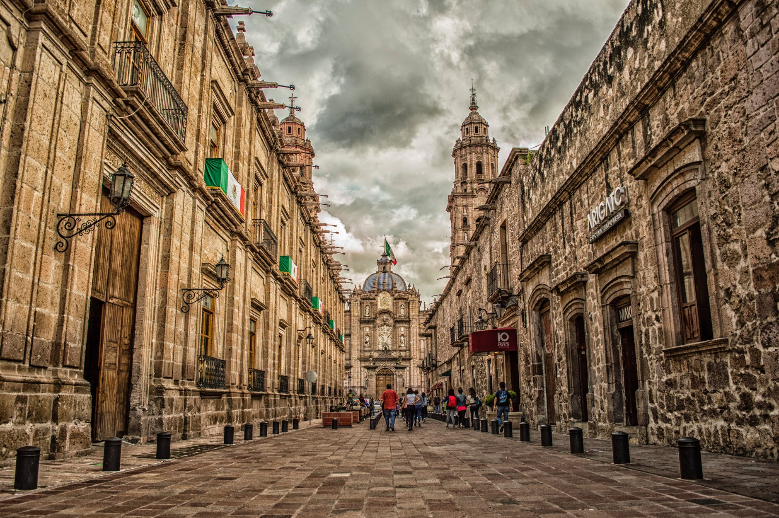
Breakfast at the hotel.

We will visit Morelia, a World Heritage City, known for its good student atmosphere and its magnificent colonial buildings of pink quarry stone: The Cathedral, the Government Palace, the Clavijero Palace, the Plaza Mayor, the typical candy market, the Aqueduct and the Gualupita Temple in the San Diego Convent. Return to Mexico City.

Check in at the hotel
Lunch and dinner on your own. Lodging.

DAY 11 (Thursday) – MEXICO / OUT

Breakfast at the hotel.

At a convenient time, transfer from your hotel to the Mexico City International Airport to take your flight to your destination.

END of SERVICES

HOTELS 4*

City | Nights | Hotels
Mexico City | 04 | Casa Blanca or similar
San Miguel de Allende | 01 | Real de Minas or similar
Guanajuato | 01 | Holiday Inn Express or similar
Zacatecas | 01 | Santa Rita or similar
Guadalajara | 02 | Morales or similar
Morelia | 01 | Alameda or similar

PRICE includes:
- Tourist transportation with air conditioning.
- Bilingual guide
- 10 nights’ accommodation in the mentioned hotels
- 10 breakfasts in hotel
- 01 Buffet lunch without drinks
- Visits mentioned with the corresponding admissions
- Local and lodging taxes
NOT INCLUDED:
- Air tickets
- Extra visits or not mentioned in the program
- Airport taxes
- Meals not mentioned in the program
- Drinks
- Extras for passengers
- Tips to guide and driver

IMPORTANT REMARKS:

- If flights arrive or depart to and from the new Felipe Angeles airport, it generates a supplement.
- Please note that prices for children are as long as they are under 11 years old and share room with 2 adults, otherwise, they will have to enter in 1 TRIPLE room paying as an adult.
- TRIPLE rooms have only 2 double beds.
- Please contemplate the schedule of Check In 15:00 hrs and Check Out 12:00 hrs.
- The waiting time for arrival transfers is 2 hours and 15 minutes. After this time, passengers must arrange their own transportation.
- The grace period for departure transfers is 10 minutes. After this time, the vehicle will leave, and passengers must arrange their own transportation to the airport. *Under no circumstances are we responsible for any additional expenses incurred due to this situation.
- Ask your executive if there are more people registered on the date you are interested in.

