CIRCUIT

MAYAS Y CARIBE
09 days/ 08 nights

(Mexico City, Anthropology Museum, Square of the 3 cultures, Basilica of Saint Mary of Guadalupe, Pyramids of Teotihuacan – Tuxtla – San Cristóbal de las Casas – Palenque – Campeche – Mérida - Cancún)
Minimum 02 persons.
02 Monthly Departures

Departure’s date 2026:

JANUARY | 11 | JULY | 12
FEBRUARY | 8 | AUGUST
MARCH | 8 | SEPTEMBER | 6
APRIL | 19 | OCTOBER | 11
MAY |  | NOVEMBER | 22
JUNE | 14 | DECEMBER | 66
** Ask your executive if there are more persons signed up on the date you are interested in.

ITINERARY

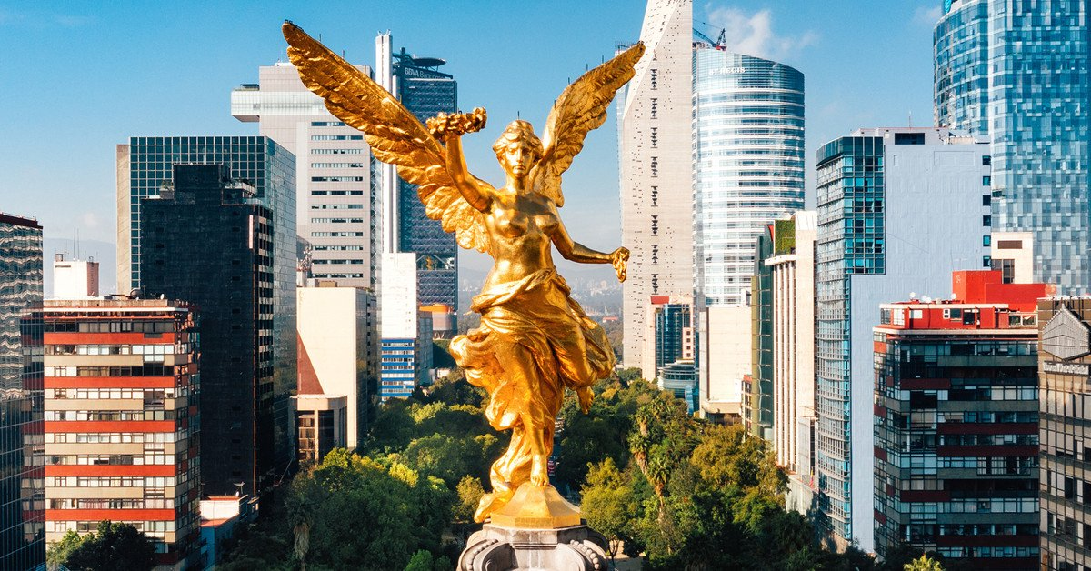
DAY 01 (sunday) – IN / MEXICO CITY

Arrival at the international airport of Mexico City.
Transfer and assistance from the airport to the hotel. Check in. Rest of the day free
Lunch and Dinner on our own. Lodging.

DAY 02 (monday) – MEXICO CITY – Pyramids of Teotihuacan + Basílica of Saint Mary of Guadalupe

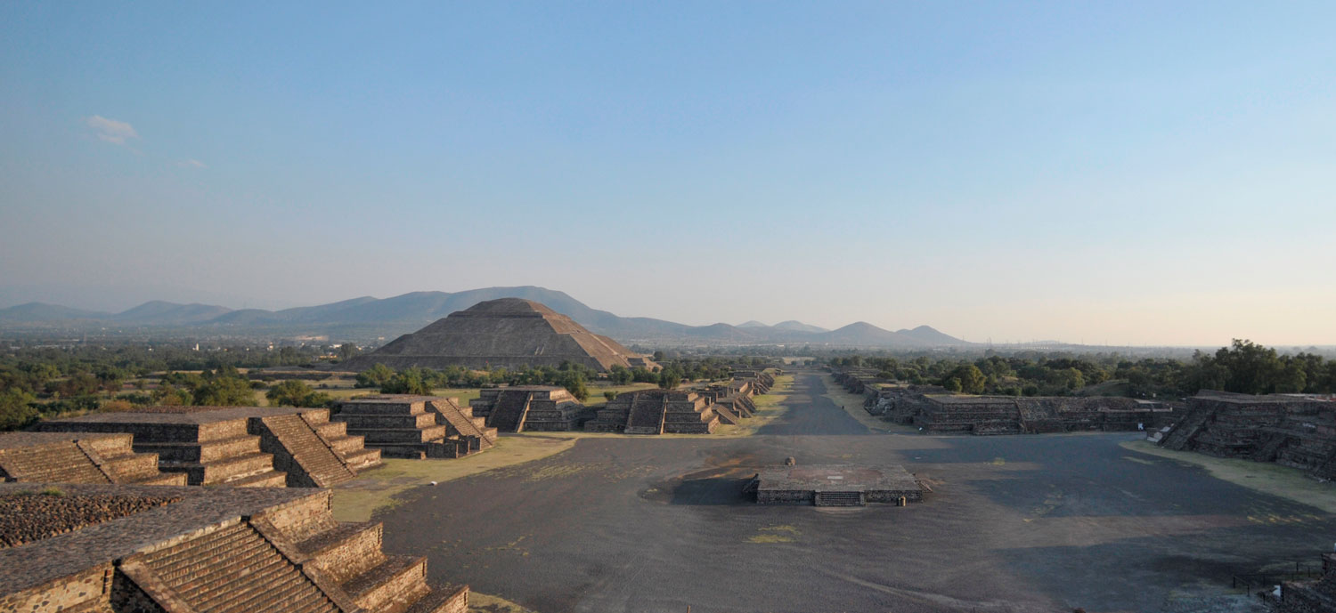

Breakfast at the hotel
Panoramic visit to the Square of the 3 Cultures historical site where the last fight between the Aztecs and the Spanish was fought and which symbolizes the fusion of 3 cultural eras represented by the Aztec ruins; the church of Tlatelolco and the building of the Ministry of Foreign Affairs. We will continue towards the Basilica of Saint Mary of Guadalupe; where we will see the original image of the Virgin of Guadalupe. You will learn how it was captured on the mantle of the indigenous Juan Diego and see the old basilica at the foot of the Tepeyac hill. On a modern highway, we will go directly to the archaeological zone of Teotihuacán; the city of the Gods; 50 km away where we can admire the impressive pyramids of the sun and the moon; Walking along the Avenue of the Dead, we will visit an obsidian workshop for the demonstration of this and the maguey. Buffet lunch (without drinks).
Dinner on our own. Lodging.

DAY 03 (tuesday) – MEXICO CITY – City tour + Anthropology Museum

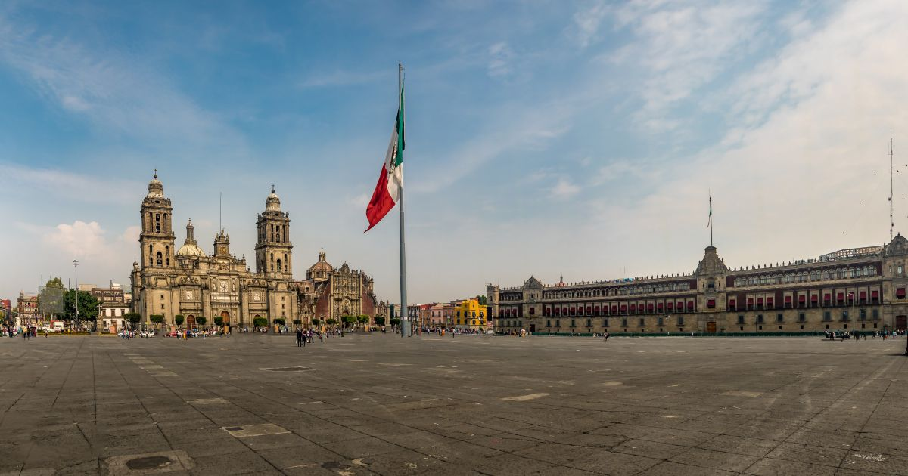

Breakfast at the hotel
We visit the Zocalo, the National Palace, panoramic view. We will see the ruins of what was the Great Temple of the Aztecs and the Metropolitan Cathedral. We will take you to the historic Chapultepec Forest surrounded by residential areas such as Las Lomas; where you will discover the residences of famous artists. Visit the National Museum of Anthropology, where you can see a mosaic of the country's most important cultures. You can stay in the museum to visit it completely or be transferred to your hotel.
Lunch and Dinner on our own. Lodging.

DAY 04 (wednesday) – MEXICO CITY / TUXTLA – Sumidero Canyon – SAN CRISTÓBAL

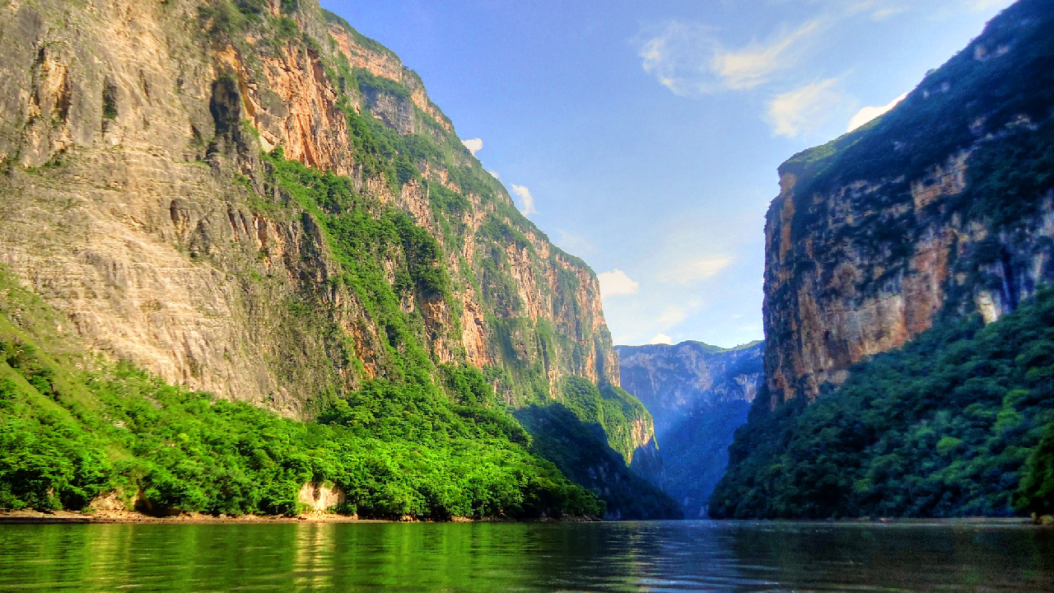

Breakfast at the hotel.
Departure transfer to the Mexico City airport to take a flight to Tuxtla. Flight is suggested at 09:30 hrs. (Flight not included). Arrive at Tuxtla airport and transfer to the pier. Boat ride through the impressive Sumidero Canyon, nearly a thousand meters high at its highest point. A brief visit to Chiapa de Corzo heading towards San Cristóbal. They must arrive on any flight before 1:00 p.m.
Check-in at the hotel
Lunch and Dinner on our own. Lodging.

DAY 05 (thursday) – SAN CRISTÓBAL – Indigenous Communities

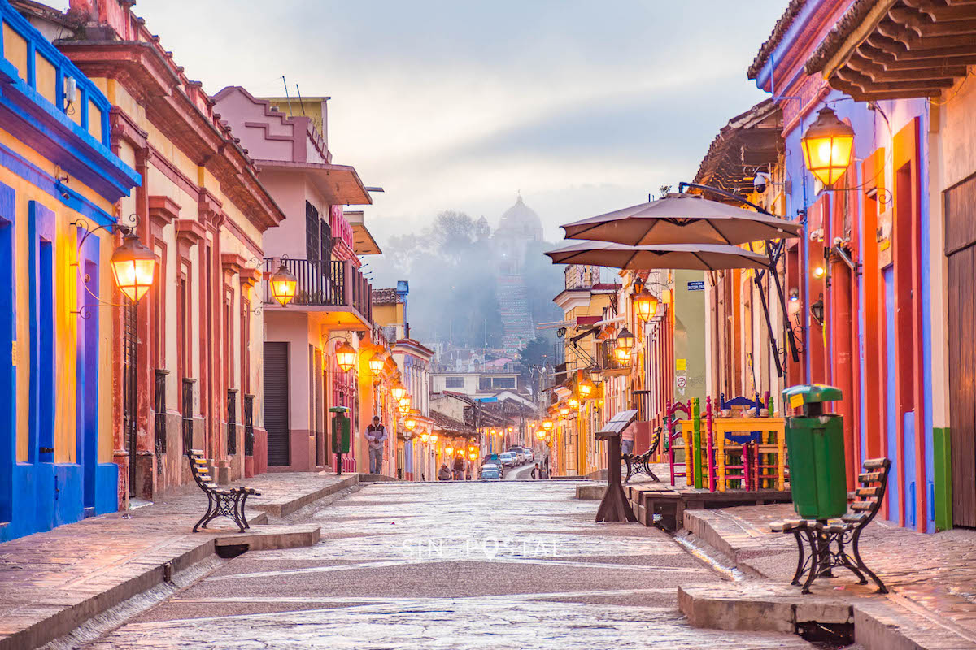

Breakfast at the hotel.
We will be San Juan Chamula and Zinacantan, native indigenous populations, who preserve their traditions, language, religious beliefs, and social organization. The Church, housing, and clothing are worthy of appreciation. Free afternoon. A good entertainment option is to walk through this beautiful city and visit the typical Market, Santo Domingo, the Cathedral, the Museum of Herbalist, and the Jade Museum, where there is a duplicate of the Tomb of King Pakal
Lunch and Dinner on our own. Lodging.

DAY 06 (friday) – SAN CRISTÓBAL – Agua Azul – PALENQUE

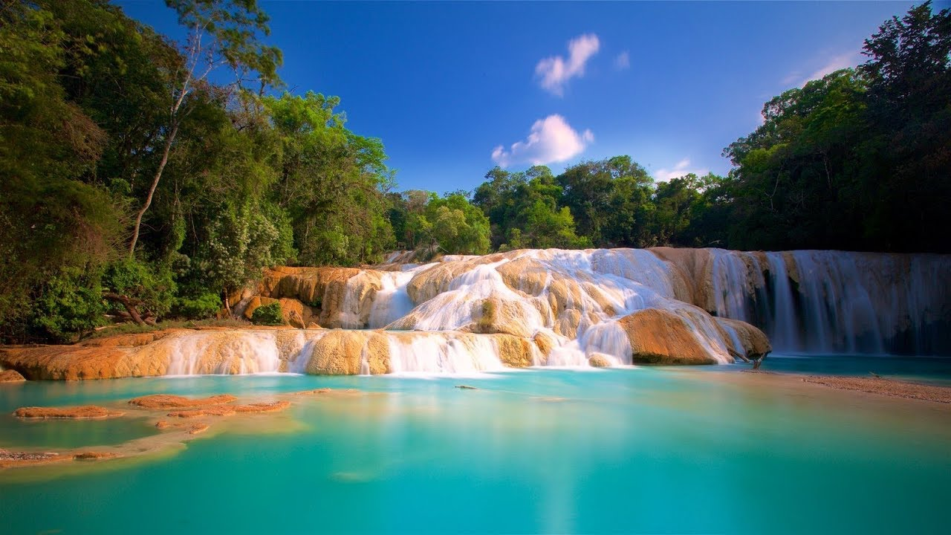

Breakfast at the hotel.
Departure from the hotel in San Cristobal to Palenque, on the way we will make a technical stop before reaching Ocosingo, and then we will visit the CASCADAS DE AGUA AZUL set of rapids, falls, and backwaters of a tributary of the Tulija River, captivates the beauty of the river, its brightness, and intense turquoise color. Continuation to Palenque.

Check-in at the hotel.
Lunch and Dinner on our own. Lodging.

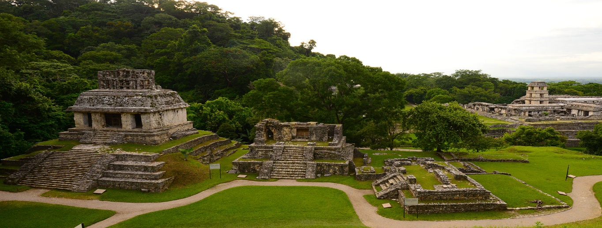
DAY 07 (saturday) – PALENQUE – CAMPECHE

Breakfast at the hotel.
We will visit the archaeological zone of Palenque, nestled in the jungle. One of the most important in the Mayan World, both for its historical finds and for its beauty. Inside the Pyramid of Inscriptions, the sarcophagus of King Pakal was found, with a tombstone engraved in relief. Temple of the Foliated Cross, Temple of the Sun, and the Palace. Continuation to find a beautiful panoramic view of the Gulf of Mexico.

Check-in at the hotel.
Lunch and Dinner on our own. Lodging.

DAY 08 (sunday) – CAMPECHE – Uxmal – MÉRIDA

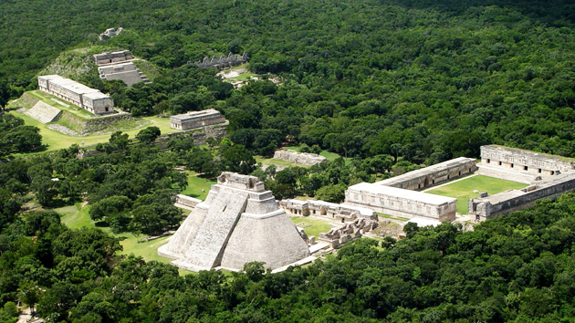

Breakfast at the hotel
City tour of Campeche and departure to Uxmal. Visit this archaeological area of ​​great architectural beauty: the Pyramid of the Fortune Teller, the Nuns' Quadrangle, the Governor's Palace, and the Ball Court. Lunch and continuation to Mérida, "The White City" where we will take a short tour: The Montejo promenade, the monument to the Homeland, the Main Square with the Cathedral, and the Government Palaces.

Check-in at the hotel.
Dinner on our own. Lodging.

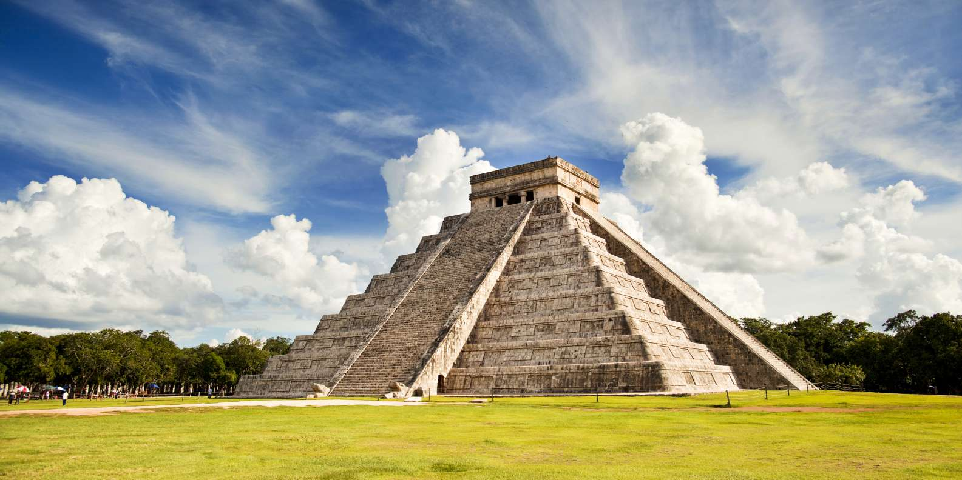
DAY 09 (monday) – MERIDA – Chichen Itza – CANCUN

Breakfast at the hotel
We will continue to Chichen Itza, the most recognized Mayan city in Mexico. Archaeological site where advanced archaeo-astronomical knowledge is revealed. It has the stepped pyramid called the Castle or Temple of Kukulkan, the Ball Court, the platform of the Skulls, the Temple of the Jaguars, the Observatory, the Square of a Thousand Columns, and the Sacred Cenote. Lunch. Continuation to your hotel in Riviera Maya or Cancun.

END OF THE SERVICES

HOTELS 4*
City | Nights | Hotel
Mexico City | 03 | Casa Blanca or similar
San Cristóbal | 02 | Sombra del Agua or similar
Palenque | 01 | Piedra de Agua or similar
Campeche | 01 | Plaza Campeche or similar
Mérida | 01 | Gran Real Yucatán or similar

THE PRICE Includes:

- Tourist transport with air conditioning.
- Bilingual guide
- 08 nights of lodging in the hotels mentioned
- 08 Breakfast at hotel
- 03 Lunch without drinks
- Visits mentioned with the corresponding admissions
- Local and lodging taxes

NOT INCLUDED
- Air tickets
- Extra visits or NOT mentioned in the program
- Airport taxes
- Meals not mentioned in the program
- Drinks
- Extras for passengers
- Tips to guide and driver
OBSERVACIONES IMPORTANTES:

- Please note that prices for children are as long as they are under 11 years old and share a room with 2 adults, otherwise they will have to enter 1 TRIPLE room paying as an adult.
- If flights arrive or depart to and from the new Felipe Angeles airport, it generates a supplement.
- The TRIPLE rooms have only 2 double beds
- Please consider the Check-in time at 15:00 hrs. and Check-out at 12:00 hrs.
- Ask your executive if there are more people signed up on the date, you're interested in.

