CIRCUIT

ESENCIA COLONIAL
07 days /06 nights

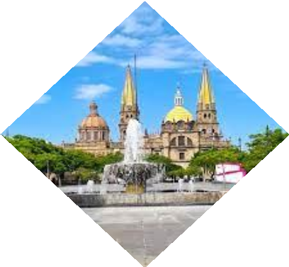
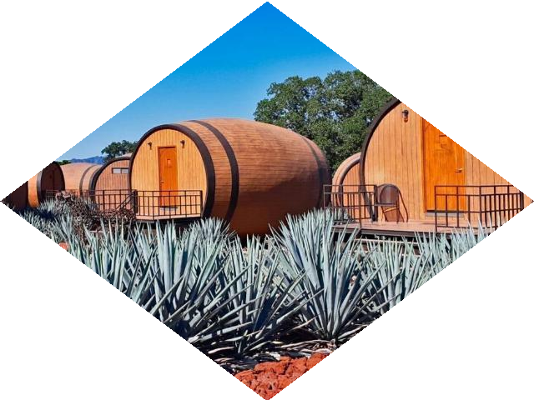
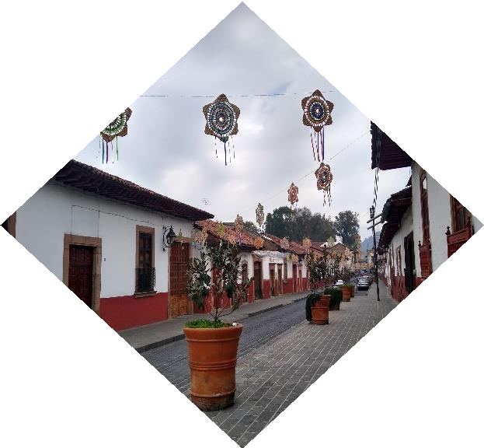

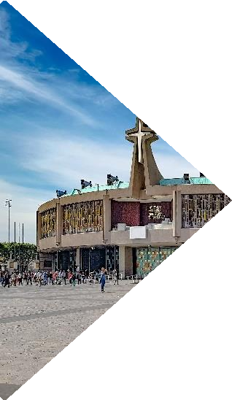
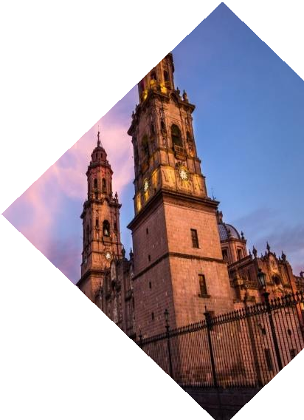

(Mexico City, Guadalajara, Tlaquepaque, Tequila, Guanajuato, San Miguel de Allende, Queretaro, Mexico City)

Minimum 02 persons.
01 Monthly Departures

Departure’s date 2026:

JANUARY | 10 | JULY | Not applicable
FEBRUARY | 07 | AUGUST | 08
MARCH | 07 | SEPTEMBER | 12
APRIL | 11 | OCTOBER | 03
MAY | 09 | NOVEMBER | 07
JUNE | Not applicable | DECEMBER | 19
** Ask your executive if there are more persons signed up on the date you are interested in.

ITINERARY
DAY 01 (Saturday) – IN / MEXICO CITY
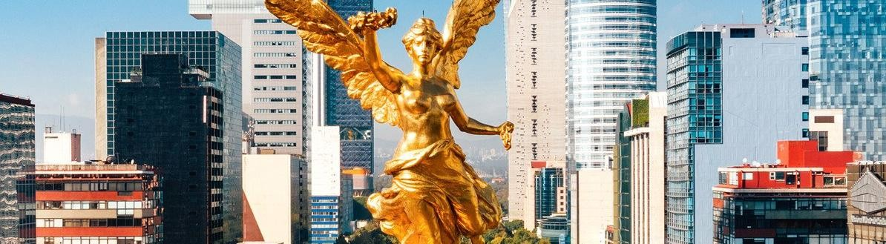
Arrival at the international airport of Mexico City.
Transfer and assistance from the airport to the hotel. Check in. Rest of the day free
Lunch and Dinner on your own. Lodging.

DAY 02 (Sunday) – MEXICO CITY – GUADALAJARA – City tour

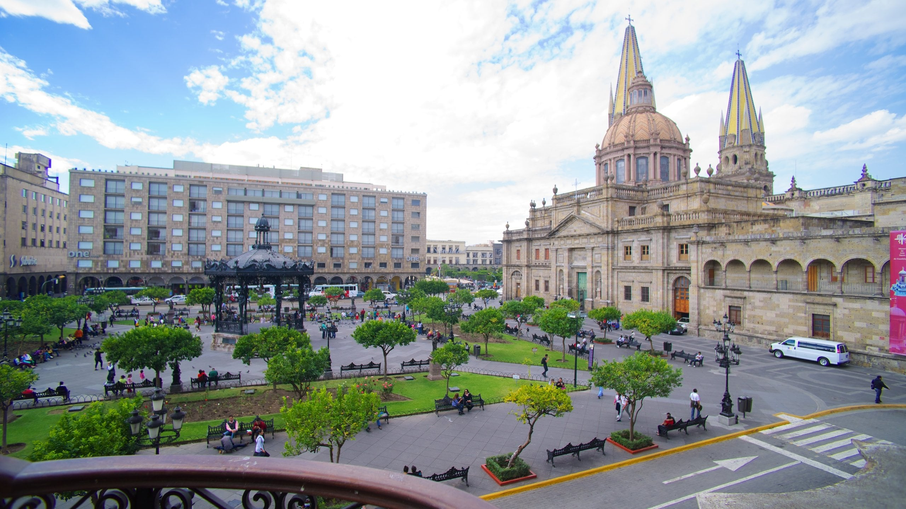

Breakfast at the hotel

In the morning, we will depart from Mexico City for Guadalajara, also known as "The Pearl of the West" for its beauty. Upon arrival, we will tour Guadalajara, visiting the Cathedral, the Rotunda of Illustrious Men, the Degollado Theater, Plaza Tapatia, and enjoying a panoramic view of the Hospicio Cabañas, a UNESCO World Heritage Site.

Check-in at the hotel.
Lunch and Dinner on your own. Lodging.

DAY 03 (Monday) – GUADALAJARA – Tequila - Tlaquepaque

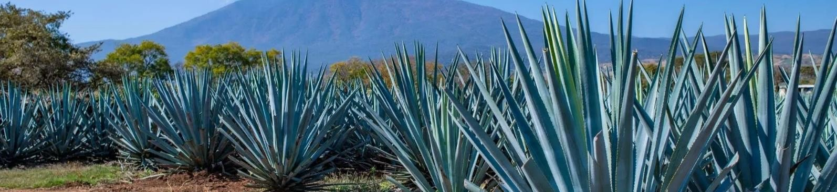

Breakfast at the hotel

At the appointed time, we will depart for Tequila, a Pueblo Mágico named after the ancient and famous Mexican spirit. We will visit one of the best distilleries where you can observe the production process. After this visit, we will continue to San Pedro Tlaquepaque, a town near Guadalajara that is now part of the city. The inhabitants of this town are dedicated to glassblowing, and you can also find spectacular handicrafts of all kinds. Return to Guadalajara.

Lunch and Dinner on your own. Lodging.

DAY 04 (Tuesday) – GUADALAJARA – Guanajuato – SAN MIGUEL DE ALLENDE
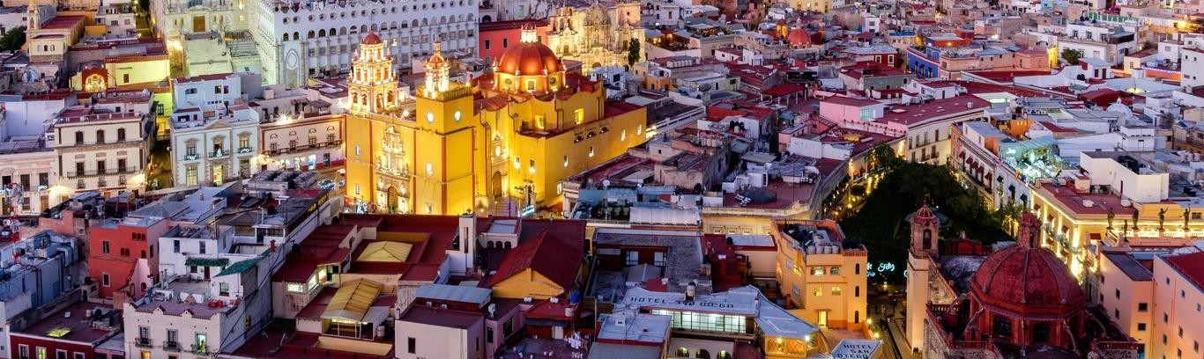

Breakfast at the hotel

Departure for Guanajuato, a UNESCO World Heritage city and home to the annual Cervantine International Festival. In the afternoon, we'll explore this beautiful city, with its charming alleyways and plazas, and discover fascinating sites such as the University, the Juarez Theater, the Alley of the Kiss, and the Diego Rivera House-Museum, the home of muralist Diego Rivera, husband of Frida Kahlo. We'll also explore its unique underground streets and avenues. In the mid-afternoon, we'll continue our journey to San Miguel de Allende.

Check-in at the hotel.
Lunch and Dinner on your own. Lodging.

DAY 05 (Wednesday) – SAN MIGUEL DE ALLENDE– Queretaro – MEXICO CITY

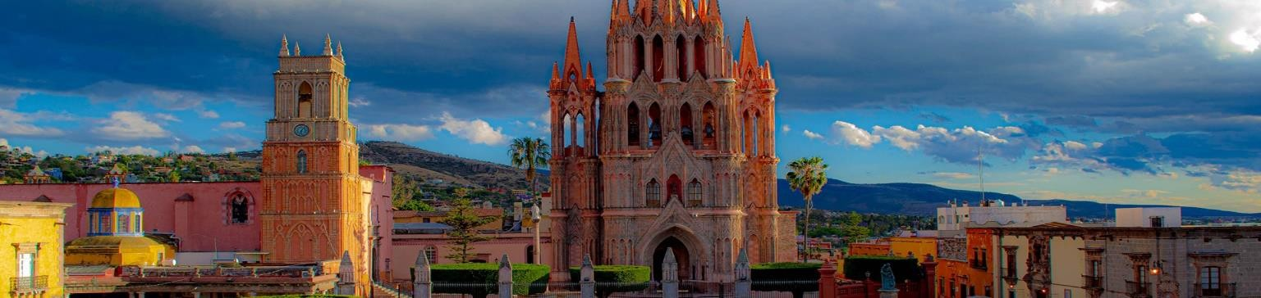

Breakfast at the hotel

Iniciamos nuestro recorrido para conocer esta apacible ciudad donde radicó el gran comediante Mario Moreno "Cantinflas" y lugar de residencia de artistas e intelectuales. Destacan como lugares importantes la Parroquia de San Miguel Arcángel, la Capilla de la Santa Casa, el Convento de la Concepción, la Iglesia de San Francisco y la Casa e Instituto Allende. Encontrará una gran variedad de cafés y restaurantes para elegir o pasear por sus calles y plazuelas. Continuamos hacia Querétaro, ciudad Patrimonio de la humanidad, donde visitaremos el Acueducto, el Ex-Convento de la Cruz y el Centro Histórico, Plaza de la Corregidora, Teatro de la República. Regreso a la Ciudad de México

Check-in at the hotel.
Dinner on your own. Lodging.

DAY 06 (Thursday) – MEXICO CITY - City tour + Museum of Anthropology or Chapultepec Castle

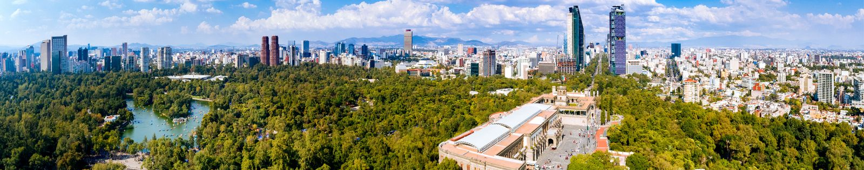

Breakfast at the hotel

We will visit the most representative places in this city. The first part is on foot. The Plaza de la Constitution, or Zocalo, is the third largest square in the world. On its sides, we will find the first attractions we will see: The National Palace, the Metropolitan Cathedral, the largest church in Latin America, where we can appreciate, among other things, the famous "Santo Cristo del Veneno" or "Black Christ." Next to the Cathedral are the ruins of the Templo Mayor, which is precisely the heart of the birth of Great Tenochtitlan, which we will view from the outside. From here, we will admire Paseo de la Reforma from the vehicle, with its Independence Monument commonly called "El Angel". If the authorities allow it, we can get out to take a photograph with Mexico's most important monument. We will continue along Reforma to locate and admire from the vehicle Chapultepec Forest, where the Castle, which was the residence of Emperor Maximilian and Mexican presidents, the Lake, and the National Auditorium are located.

Option 1: Visit the National Museum of Anthropology, where you can appreciate a mosaic of the country's most important cultures.

Option 2: Visit the National Museum of History, also known as Chapultepec Castle, the former residence of Emperor Maximilian.

You can remain at the museum to explore it fully or be transferred back to your hotel.

Dinner on your own. Lodging.

DAY 07 (Friday) – MEXICO CITY / OUT
Breakfast at the hotel

At a convenient time, transfer from your hotel to the Mexico City International Airport to take your flight to your destination.

END OF THE SERVICES

HOTELS 4*
City | Nights | Hotel 4*
Mexico City | 03 | Casa Blanca or similar
Guadalajara | 02 | Morales or similar
San Miguel de Allende | 01 | Real de Minas or similar

THE PRICE Includes:
- Tourist transport with air conditioning.
- Bilingual guide
- 08 nights of lodging in the hotels mentioned
- 08 Breakfast at hotel
- Visits mentioned with the corresponding admissions
- Local and lodging taxes

NOT INCLUDED
- Air tickets
- Extra visits or NOT mentioned in the program
- Airport taxes
- Meals not mentioned in the program
- Drinks
- Extras for passengers
- Tips to guide and driver

IMPORTANT OBSERVATIONS:

- If flights arrive or depart to and from the new Felipe Angeles airport, it generates a supplement.
- Please note that prices for children are as long as they are under 11 years old and share a room with 2 adults, otherwise they will have to enter 1 TRIPLE room paying as an adult.
- The TRIPLE rooms have only 2 double beds
- Please consider the Check-in time at 15:00 hrs. and Check-out at 12:00 hrs.
- The waiting time for arrival transfers is 2 hours and 15 minutes. After this time, passengers must arrange their own transportation.
- The grace period for departure transfers is 10 minutes. After this time, the vehicle will leave, and passengers must arrange their own transportation to the airport. *Under no circumstances are we responsible for any additional expenses incurred due to this situation.
- Ask your executive if there are more people signed up on the date, you're interested in.

