PROGRAM
PROGRAM 5
05 days / 04 nights

(City, Basilica of Guadalupe, Pyramids of Teotihuacan, Taxco or Puebla / Tonantzintla)

Minimum 2 persons.
Daily departures

ITINERARY

DAY 01 – IN / MEXICO CITY

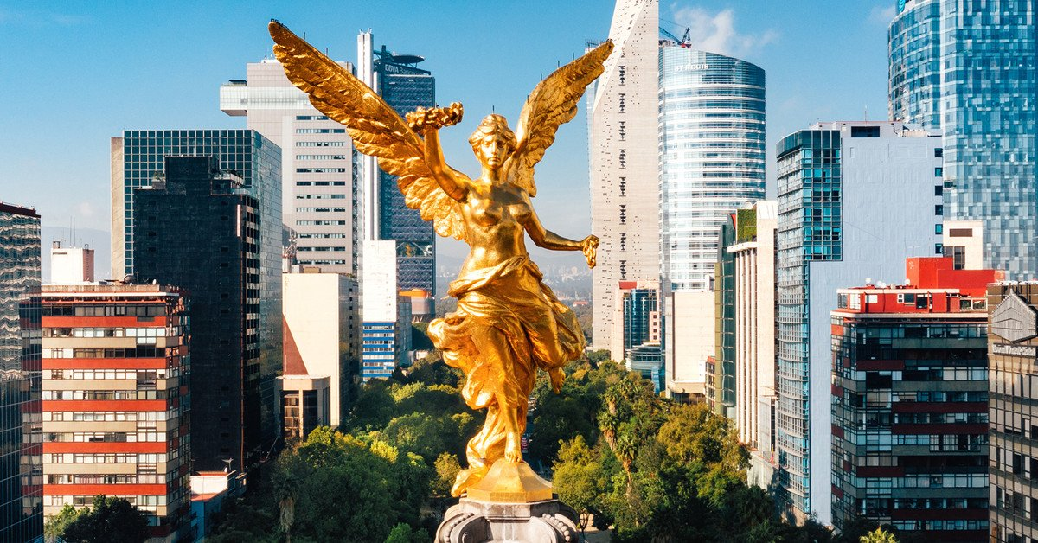
Arrival at Mexico City International Airport. Reception and transfer to your hotel.
Check in at the hotel. Rest of the day at leisure.
Lunch and dinner on your own. Lodging.

DAY 02 MEXICO CITY – City Tour

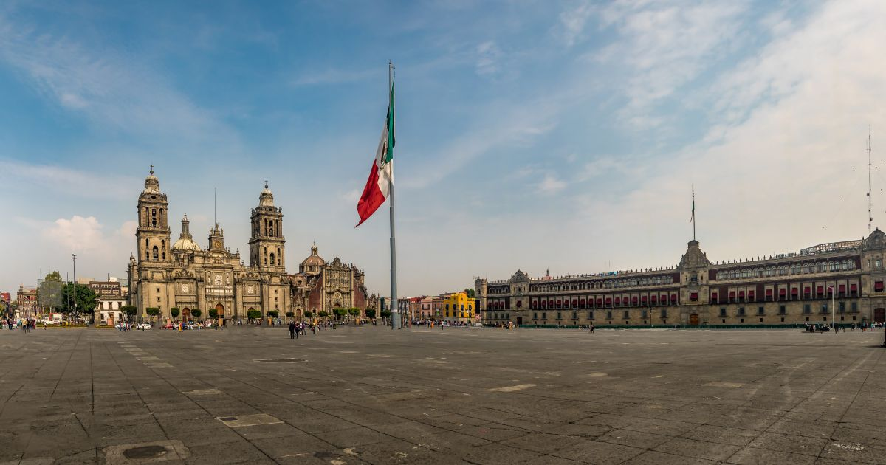

Breakfast at the hotel.
Visit the Zócalo, the National Palace (outside view). We will see the ruins of what was the Templo Mayor of the Aztecs and the Metropolitan Cathedral. We will take you to the historic Chapultepec Forest surrounded by residential areas such as Las Lomas, where you will see the residences of famous artists.
Lunch and dinner at leisure. Lodging

DAY 03 – MEXICO CITY – Basílica + Pyramids

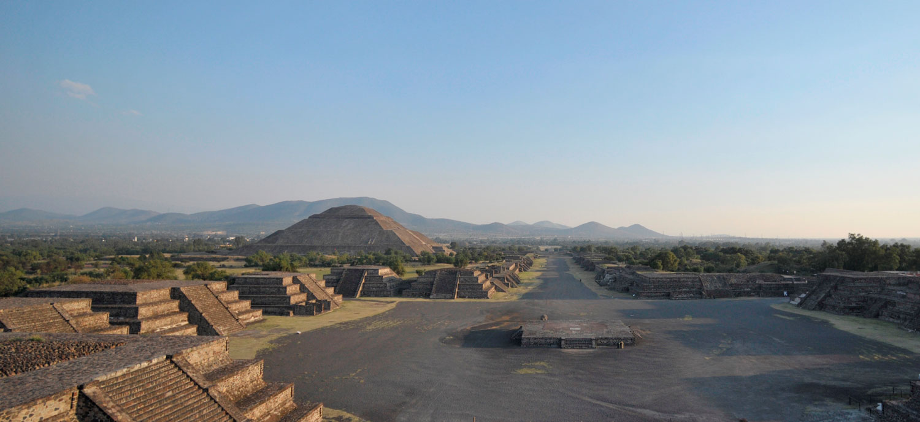

Breakfast at the hotel.
Panoramic visit to the Plaza de las Tres Culturas; historical site where the last fight between Aztecs and Spaniards was fought and which symbolizes the fusion of 3 cultural eras represented by the Aztec ruins; the church of Tlatelolco and the building of the Ministry of Foreign Affairs. After a short stop, we will continue to the Basilica of Guadalupe, where we will see the original image of the Virgin of Guadalupe. You will learn the story of how it was captured on the mantle of the indigenous Juan Diego and see the ancient basilica at the foot of the Tepeyac hill. By a modern highway we will go directly to the archaeological zone of Teotihuacan; the city of the gods; 50 km away where we will be able to admire the impressive pyramids of the sun and the moon; walk along the avenue of the dead; we will visit an obsidian workshop for the demonstration of this and the maguey.

Lunch and dinner at leisure. Lodging

DAY 04 – MEXICO CITY – Taxco (OPTIONAL CAN BE EXCHANGED FOR PUEBLA ONE DAY WITHOUT FOOD

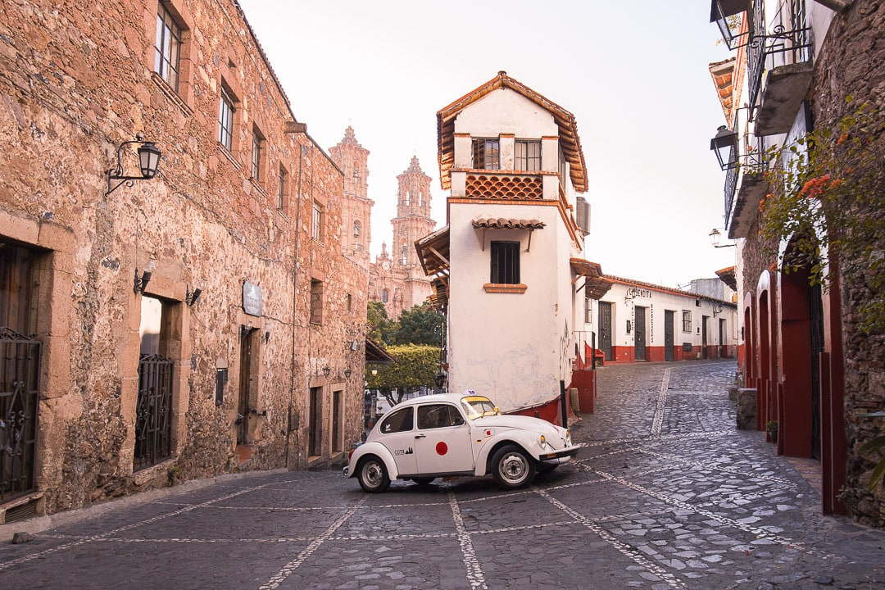

Breakfast at the hotel.
Departure to Taxco, where we will admire the picturesque architecture, highlighting the church-Cathedral of Santa Prisca, and admire the beautiful handicrafts made of silver. Free time at leisure. Return to Mexico City.

Lunch and dinner at leisure. Lodging

- Puebla / Tonantzintla operates: Tuesdays and Thursdays - 10 a.m. to 12 p.m.

DAY 05 – MEXICO CITY / OUT

Breakfast at the hotel.

At the convenient time transfer from your hotel to the airport to catch the flight to your destination.

END of SERVICES

CITY | NIGTHS | HOTELS 3** | HOTELS 4* | HOTELS 4**
Mexico City | 03 | Premier / Regente / Estoril | Casa Blanca / PF / Royal Reforma / Novotel | Laila / Galería Plaza

INCLUDES:
- TRANSPORTATION: Bus / Minibus or Van with air conditioning.
- ACCOMMODATION: Hotels according to your choice.
- MEALS: Daily breakfasts
- VISITS: As mentioned in the program.
- ACCOMPANYING GUIDE: Bilingual, certified by the Ministry of Tourism.

NOT INCLUDED:

- Air tickets
- Food or services not mentioned
- Taxes at the airport
- Tips to guides or drivers.

IMPORTANT REMARKS:
- Due to the multiple changes that occur daily in tourism, these prices must be confirmed at the time of booking request.
- Rates subject to availability and change without notice.
- Credit card payments apply a % commission.
- Please check in at 15:00 hrs and check out times at 12:00 hrs.
- The TRIPLE rooms only have 2 double beds.
- If flights arrive or depart to and from the new Felipe Ángeles airport, it would have to be re-quoted since a supplement is generated
- The waiting time for arrival transfers is 2 hours and 15 minutes. Once the time has elapsed, the passenger must travel at their own expense.
- The tolerance time for departure transfer is 10 min., after this time the unit is removed and must move on its own to the apartment. * Under no circumstances are we responsible for the extra expenses that arise from this situation.
- Tours may change order depending on the correspondent's operations.

